WORKING DOC FOR ADILAS SALES FLIERS:

SYSTEM PLAYERS:

Inside of Adilas there are 12 main groups we call “system players”. These main system players hold, organize, and store your data to reflect your business operations. They are:

- Customers
- Invoices
- Quotes
- Vendors
- PO’s (Purchase Orders)
- Parts (Inventory Items or Business Services)
- Stock/Units (Serialized Inventory)
- Deposits
- Expense/Receipts
- Employees/Users
- User-Maintained Balance Sheet Items
- Elements of Time (Calendar & Scheduling)

There is no limit to the number, or usage, of each player. These players work together to track your business operations and needs. Your data, your way!

Customers • Invoices • Quotes • Vendors • PO’s (Purchase Orders) • Parts (General Inventory Items) • Stock/Units (Serialized Inventory) • Deposits • Expense/Receipts • Employee/Users • User-Maintained Balance Sheet Items • Elements Of Time (Calendar & Scheduling)

ECOMMERCE:

E-Commerce
Adilas automates the e-commerce experience. All inventory is tracked and updates in real-time as people purchase from your website. Custom skins brand Adilas with the look and feel of your company. Because e-commerce is attached to Adilas, all purchases from e-commerce immediately affect the inventory database within the system. This makes your e-commerce a direct asset and connection to your business.

ADILAS E-COMMERCE
A powerful solution to your E-commerce needs. This powerful new E-commerce template for Adilas contains a vast amount of upgrades. Some of these upgrades include a pricing matrix for shipping, per line item shipping costs, custom e-mails for quotes/order and invoices. Four new display options, online bill pay, invoice and quote options and so much more. Over 100 new settings have come into this new template to make it more dynamic, more powerful, and more customizable. Watch our into video, take a tour

ADILAS E-COMMERCE PROVIDES
- Customizable
- Advanced e-mail settings & E-mail departments
- Advanced shipping options
- Online Bill Pay
- and so much more

Adilas automates the e-commerce experience. All inventory is tracked and updates in real-time as people purchase from your website. Custom skins brand Adilas with the look and feel of your company. Because e-commerce is attached to Adilas, all purchases from e-commerce immediately affect the inventory database within the system. This makes your e-commerce a direct asset and connection to your business.

Adilas automates the e-commerce experience. All inventory through e-commerce is real-time. Purchases automatically effect your inventory values within your Adilas system. Live quantities are displayed on the web.

All inventory is tracked and updated in real time as purchases are made from your website. Custom interfaces allow e-commerce to take on the look and feel of your company.

NOTES ON SALES FLIERS WITH BRANDON 1/22/19 & 1/29/19:

***SELF-SERVE MODEL - Explain realistic expectations for our model - We leave it in your hands - you are on your own to be successful and find the people that will help you be successful
-ADILAS really shines when you work with a rep/consultant - determine your work flow, start with different bite size pieces & achievable goals all at first, set an achievable goal with the realistic learning curve,
-Custom needs/work needs to be processed through a Project Management process - determine scope of work, time frame, quote
-Requirements are to pay your monthly but to truly be successful you really want to get a rep/consultant for training, for managing the system, for

-Looking around a $2000-$5000 to get up and going with training and setup or more to get into the game - even an EZ setup often needs data migration, start up, training,
-This system does take work and input for it to give you the outputs you want - how to say this well in a sales pitch???

RESOURCES/INFO:
Info from Brandon: link to some good (older) info: https://www.adilas.biz/intro_to_adilas.pdf

See this element of time for notes from the session with Kelly. Just search for the word Kelly and you will find the MS Word doc. https://www.adilas.biz/top_secret/time_web_gallery.cfm?corp=748&id=3957

Brandon sent another email with a graphical flyer that has a nice flavor and may give us some ideas.

***HOW TO BE SUCCESSFUL PAGE -
-Re-listen to Kelly’s portion of training for some notes, ideas, etc.
-Is this a good fit or a bad fit for this client?
-This is not a fit for everyone - some people LOVE Adilas and it is not a fit for others - the product has so many capabilities and great potential - what do they want to do with it??
-Adilas is not for everyone and it is important for the client to decide and to make that decision?
-If you are detail oriented and want some of the things your system can give you….
-You have to invest in Adilas to be successful in Adilas - “we sell potential”
-The word “standard” has come up from multiple clients. They have told multiple of us, “What? This should be standard.” When they have thousands of other features at their fingertips. We are an AS-IS product. We have so many features and pros and we will keep building and improving, but anything that you want beyond what is there and our development process is custom and will be motivated by the client and where they want product
-Kelly has an initial consulatation with clients to see if Adilas is even a good fit for them. What is it that they want? Does that fit well with Adilas? What are their needs, biggest goals, desires? Get an idea of what their needs and biggest pains are before demoing.
-How do we do this to help sales but we want to sell it to those who really want what we have to offer. We want to give realistic expectations so we can all have a better experience and have success.
-Get the top 10 data points before we look to move to further versions, things
-It can do so many things it makes you assume you can automatically walk in and get anything you want… There is SO MUCH that it can do but depending on how it gets presented you have different expectations.
-Even though it can do SO MUCH - you really need to have an understanding of HOW we really operate and WHAT it really takes to operate before you decide
-Current basic requirements are setup & a monthly - but clients really need someone (consultant) to help them be successful
-We are small & in order to keep our costs low and their monthly costs low we have the training as an external feature and product/service
-We need to clear the assumption that we do everything - it is on them
-How do we help people get good clients? - The Marketplace
-A lot of client’s success depends on training and consultant
-Instead of EZ setup at $1000 - maybe we need to be at least $2000 and add training in there because that is a must
-People like our price, our functionality, customizability - we need to clarify other points of concern
*Re-watch Kelly’s session & takes notes - follow-up with this next time
-We need to setup some ground rules - boundaries - this is how we play and this is what you can realistically expect from us.

-May want to mention about hardware, software, merchant processing - you have to set these things up or have that setup process and training….
-We can do almost anything that people want but who is putting gas in the tank… We need to have boundaries ourselves - establish those, establish those ground rules and help people understand how they need to play in our environment - we get to determine how we play and then we can allow people to choose if they want to play in our world and environment.
-Common verbage so that we can communicate who we are, what we do, how our model works… There is not a contract, this is how it works and this is what you are getting into?

Notes from Kelly’s Training Session: (Brandon & I relistening to it on 2/5/19 & some of our thoughts & notes from discussion)
- Can you operate adilas in a transparent manner? That is the challenge and the power of Adilas.
- It’s not a turn on and run itself system.
- Adilas is meant to reflect the operations that are happening physically
  - What are you physically doing? What are you doing?
  - Determine the work flow - what physically happens
  - Document the process
  - How are you going to use that to operate the system
- Break down the work flows before setup - sets you up for success
- Discuss the physical & who touches what
- What documentation do you want uploaded to verify those actions
- Document this initial work flow, setup meeting so that you have supporting documentation to help them when they ask you further questions
- We can only help them as much as the information they provide
- What do they have to do touch - such as 3rd part processes as well - state tracking systems
- Keep it simple - especially at the outset
- Start small, simple
  - Pick top 10 data point 1.0 and get successful with that first
  - Once that is set - then we can work for 2.0
- ****Set & define CLEAR expectations in the beginning****
- Speak realistically & be grounded in fact
  - What is the system capable of RIGHT this minute
  - Yes we can do so many things - but WHAT is BUILT & READY to USE RIGHT NOW
- Business therapy - different owners, managers, support staff - different expectations
  - Set it clear in the beginning
  - Who does what?
  - Keep a record of that in the system
  - Document things in their system & ours - avoiding litigation
  - Keep yourself transparent
- Adilas is better at than any other system - when used transparently is AMAZING
  - If you don’t want to use the system transparently - that is when you have a lot of the problems
  - 95% of the time the problem is NOT the system
  - 95% of the time the problem is an operating problem that is being reflected as a symptom in the system
  - Try to get a physical run-down of what someone was doing to troubleshoot it what she tries to do
- What do they want in data points & what the system gives them
  - Then you can work backward to provide them with their needs
  - This directs training, setup, etc.
- Owners are different than operators
  - Talk to both - two part setup
  - What do owners want - but they also need to understand how that data is achieved.
  - Because the operators are the ones who have to put it in the system so
  - The operators have to be able to support the system & are doing the ground work for what the owner wants
  - Need to understand what is wanted & if it will work for their operation
- SAAS - We need a generic foundation that is good
  - People will want to tweak & customize - but what do we have available right now & how can we build
- EXPECTATIONS - one of the hardest things to manage
  - Here is what we are - here is what we do
  - If you love this - great, you will love us! If not, we are probably not the system for you
- Clients have different personalities and they may be more successful with a different consultant
  - Also who designed the system
  - No perfect consultant only the perfect consultant for a particular client
  - Will you need multiple consultants to maintain a system
- System Maintenance - Manage Services
- ****What do we do about the NOT REQUIRED pieces but the pieces that really make for a SUCCESSFUL EXPERIENCE WITH ADILAS****
  - Here is what successful people do
  - Almost an investment idea/approach
  - ****This is not required but this is what our MOST SUCCESSFUL people do - maybe this approach will be a better sales pitch approach than - this is what you have to do to be successful - instead this is what our most successful clients do - a different spin that helps them want to pick up the pieces, invest more & be successful themselves****
  - The more people want to invest in this process, setup, training, maintenance, the happier they will be with the outcome
- Hard to find consultants who can do it all - every aspect
  - Different consultants are good with different pieces or parts
  - Also different industries
  - Same with developers
- We all need to communicate better
- Maintenance
  - Ongoing support to help make sure they are being able to operate the system & continue being successful
  - Do they need further training - did you forget how to do something
- There is implementation & maintenance - ongoing oversight
  - Financial, inventory
  - Ongoing oversight of just a few hours a month really makes a difference in success
  - How am I going to support you in achieving your goals?
  - This conversation is so helpful up front
- Ongoing oversight creates a better relationship with the staff
  - Because then the staff is not afraid to call & get help
  - They don’t shut down as much because there is a relationship and they are continuing to learn
- Pros & Cons about different things
- Try to operate out of the box first
  - Worry about customizing later - if they can get the basics down first & get successful and then customize they are usually much happier clients
- Adilas is not for everyone - you have to want this and want what adilas has to offer
  - Also an understanding of what it takes to get what you want
  - Yes - it could do so much but are you willing to do what it takes to get what you want
  - Are you ready to take on Adilas?? Do you really want this? You have to want to be transparent? You have to want the staff to put in information. You have to be excited about the data and the reports and it means enough to you to operate this way.
- Set people up for success
  - What are some of the physical challenges in our workstations that affect our ability to use the system
- We don’t necessarily set hardware up - but we do have some recommendations
  - We don’t make any requirements here but there is a lot of frustration there because so many people don’t know how to be successful
- We have to keep working on the Adilas Marketplace
  - Because we have so many needs and outside sources - we NEED to be working on a centralized place where we can send everyone to so that we can get people the help that they need
- We are not fast & easy, wham, bam just like every one else
- ****WE NEED TO BE OUR OWN STYLE****
  - We need to play to our strengths & communicate expectations & what we do
- ****Like Carhart or something - we cater to a specific things****
  - We have a great price, super flexible solution,
  - What makes our system so different? What makes our product special?
    - Separated model (trying to marry together so many different systems) (Graphic - circle in the middle with lots of other circles off of a branch/line) (4-8 packages to run their business)
    - Systemized model (we are trying to bring it all together - creating a system where we can talk and play with each other automatically, with greater ease) (Big circle with pie pieces - all in the same circle) (One system - all your business needs)
- World Building Concepts - what kind of world do you want, let’s build what you need
  - What does your world look like?
  - What pieces do you need?
- Need something different????
  - Branding - What would help our sales appeal and something we can be onboard with that helps our branding/marketing?
- How can we boil everything down into understandable/bite size pieces?
- Maybe we need to have a way to simplify the communication of everything we can do….
- What can we do for people??
  - How can we differentiate ourselves?
  - How can we focus on all the things we have & do right now that others do not have?
  - We are heading where no one else seems to be heading - how can we sell what we have plus vision & growing potential for the future?
- Keep boiling things down
    - Great info from Kelly - things she has learned over the years & the keys that have helped make her successful
    - Her keys to success - great for training/helping others

What do we want to include on our sales flyer: (Funneling down info)
- Goals
  - To sell the sizzle
  - To let them know up front what they are getting into in a fun/inviting way but with clear expectations
  - More graphic intensive
  - Concise - boiled down version of Adilas for sales
    - How much do we want to cover?
    - Can we boil it down that simply?
- Audience
  - Owners**
  - Operators
  - How do we speak “their” language?
    - A generic language?
    - Do we want to speak industry specific?
    - Multiple fliers?
- How do we help sell what we have & what we can do?
  - Fun Buzz words
    - Functions: POS, CRM, inventory tracking, expense tracking, calendaring/scheduling, history & reports, web presence & eCommerce, etc., etc.
      - People get excited about all the functionality - they do also start assuming things about what the system can do or how easy it might be…
- Define our lingo or things we use to describe ourself
  - Our use different/understood words to describe ourselves
  - People expect certain things if they hear certain words
    - i.e. self-serve model
- Honest -
  - How do we flip our model so that we present ourselves honestly but realistically?
  - And that we show what we can really do?
- Steve said
  - People like:
    - Our price
    - Our functionality
    - Our ability to customize
  - If that’s what people really like - then maybe this is where we need to start with sales & how we can capitalize on this & present it better
- Do we need to revamp our website
  - Make it more digestible for people that jump on
  - If you want more info - let’s point people to the website
    - Make sure the website is ready to handle it
  - Just highlights on the sales fliers
  - Make a graphical content for sales fliers - like the new doggie flier Brandon uploaded today

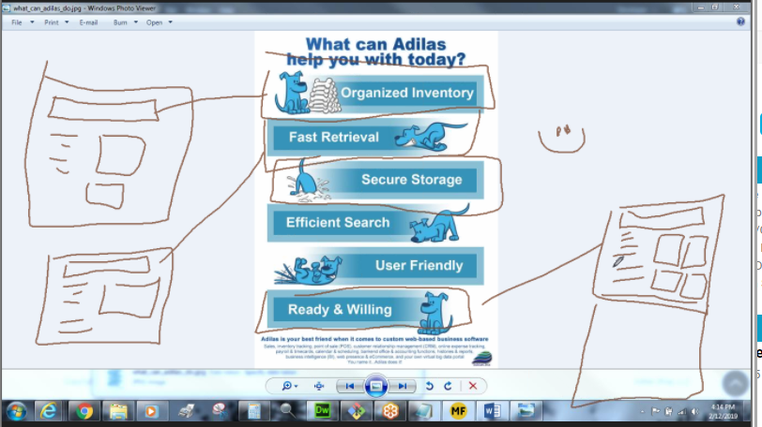

Pages:
A WHY flyer - this is WHAT we are trying to do. This is WHY we are different
- Problems we’re overcoming with our system
- World Building
- Core Concepts - This is why you want to go with us!!!!
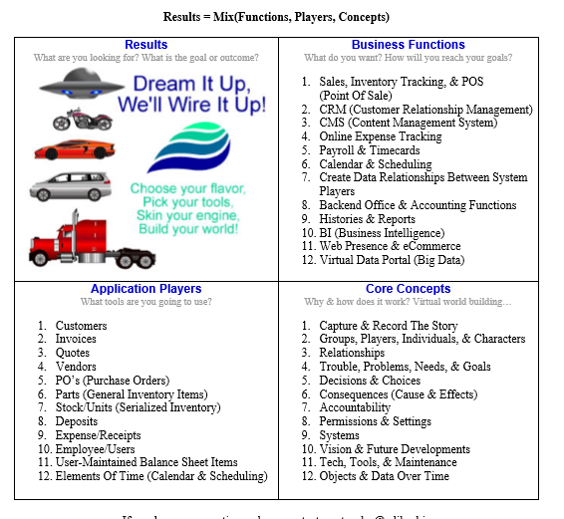

https://www.adilas.biz/adilas_formula.pdf

What really makes us different:
- Our goals & vision for the future
- World Building
- Zippering things together
  - Systemizing it
  - Letting things play together

ADILAS:
- Affordable
- Functional
- Customizeable …. Versatile

Also:
- Versatile
- Adaptable
- Flexible
- Dynamic
- Powerful
- Transparent
- Robust

Setting Clear Expectations:
- Self-serve - as-is product
- What successful clients do -or - How to be successful with Adilas - or - Most successful startups / systems - or - Most successful systems

Steps to Success: (if you really want to play this is how you engage)
- Adilas does not require these pieces but this is what our most successful clients do - or - This is what we have found our most successful clients do:
  - Work with an Adilas Consultants to:
    - Determine your company’s physical work flow
    - What do you want the system to do for you?
      - Start with realistic & achievable data points - once those are met add a new set - Version 1.0, 2.0, 3.0
    - System setup
    - Training
    - Ongoing oversight & training

Expectations:
- Care & Maintentance
- Steps to Success

Polish some graphics for helping to communicate these ideas:
Here is a link for a gallery: https://www.adilas.biz/adilas_for_business/photo_gallery_full.cfm

*The FREEDOMS & FLEXIBILITY of a self-serve model
*REAL EXPECTATIONS for SUCCESS
*Our MOST SUCCESSFUL client recipes
*Building YOUR business WORLD on SYSTEM RELATIONSHIPS
*ZIPPING UP the gaps
-Separated model vs. System model
*Telling the WHOLE STORY
*How we play the game a DIFFERENT WAY
-Separated model vs. System model
*Picking the RIGHT FIT for YOU
*THINK of WHERE WE CAN GO
-Selling potential, where you could go, what is possible
*CALLING for DREAMERS

