

It is impossible to list all of the specs that are included. You basically get a fully equipped "Virtual Data Portal". We help you with things such as sales, inventory tracking, POS (point of sale), CRM (customer relationship management), online expense tracking, BI (business intelligence), payroll, timecards, scheduling, backend office, accounting functions and much more.

We are open entry and open exit. This means:

* No Contracts
* Self-Serve
* Scalable
* Tons of permissions & settings
* Pick and choose which pieces you want to use
* No hardware or software requirements
* Always up to date
* Any device or computer that can connect to the Internet will work



Put into here…

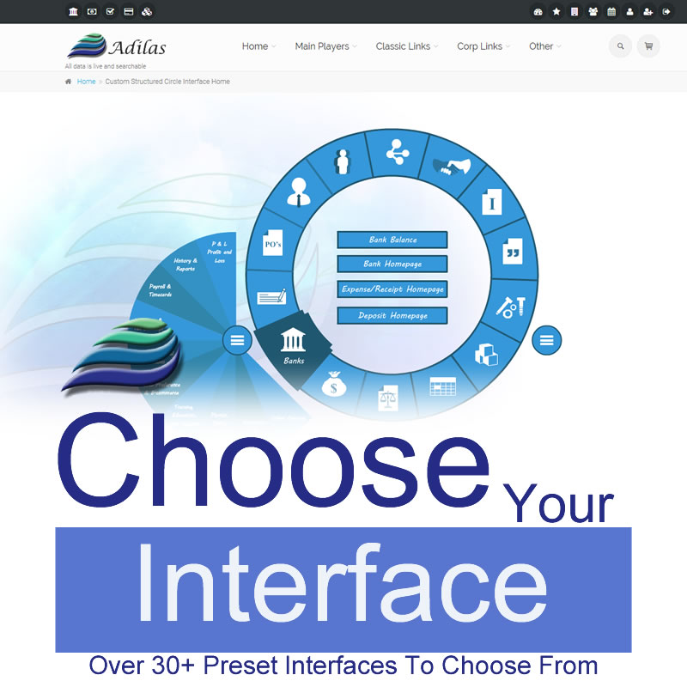

Multiple preset and pre-built homepages and interfaces. If you want your own, no problem. Feel free to flip flop between interfaces as needed. We like to use the analogy of a person working around their home. You can’t wear everything at once… If you are doing yard work, you might want your work clothes or your grubbies. Other times you might want something more formal or casual or open. Think of all of the changes that you may need if you are painting, projecting, hosting a party, lounging, etc. You get the idea.

Adilas is a web-based hosted solution. In modern language, this is commonly known as “Cloud-Based”, “eBusiness”, or “SaaS” (Software as a Service). As such, the interface is subject to change to meet your needs. This includes preset, pre-built and custom interfaces and dashboards. We like to use the phrase “Dream it up, we’ll help you wire it up!”



Put info here…

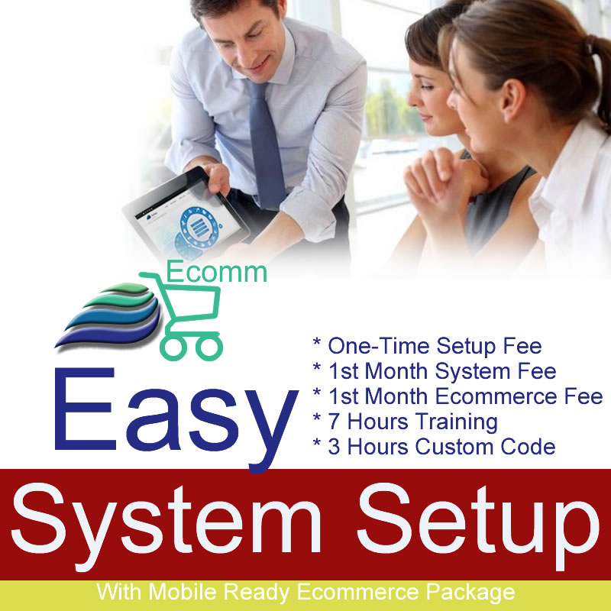

The easy adilas.biz system setup - Includes one-time setup fee, 1st month system fee, mobile ready ecommerce pkg., up to 7 hours of consulting/training and setup, up to 3 hours of either custom code work and/or simple data migration. Perfect starter package – a value of $1,256. Here is a brief rundown of what you get…

* A $250 one-time system setup fee – Turn the lights on and get your world spun up and ready to shine.
* The 1st month system fee at $189/month. We will hold that monthly fee in place for the first six months (billed separately per month). After the first six months, we will review your account with you. Contact us for a quote.
* Up to 5 hours of either setup, training, and/or consulting. A $250 value at $50/hour for 5 hours.
* Mobile ready ecommerce package. This package is valued at $267. It includes a $100 one-time ecommerce setup fee. An additional 2 hours of training for the ecommerce package at $50/hour, and the 1st month ecommerce fee at $67/month.
* Up to 3 hours of custom code or simple data migration. Basically, we have budgeted $300 for whatever you need to get you going. If more custom code is needed, we can get you a quote on that. We love ideas and dreams.

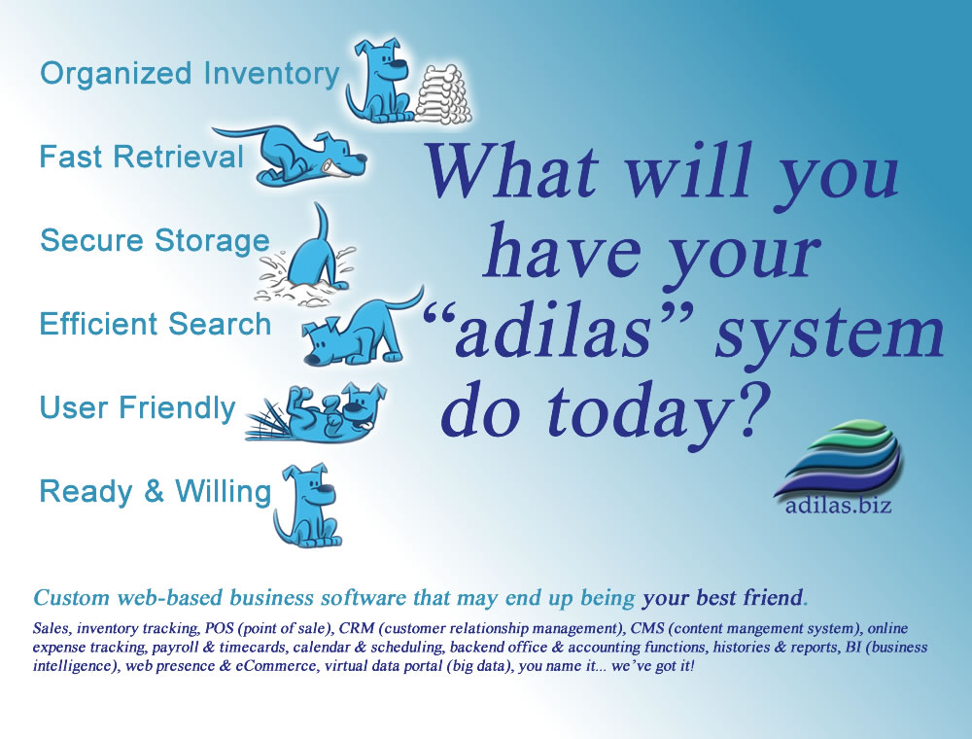

Adilas.biz is an online server-based application where you can store and track your data for your daily business operations and backend accounting needs. You own the data and have 24/7 access to the site through a valid login and password. Adilas maintains the code base and the application files. We also provide all of the future upgrades and features for FREE. We use the saying, "Your data, you cache & retrieve it, we secure it".