
Adilas 3-Part Pitch
PART 1
Introduction
Who We Are
Adilas is an all-inclusive business platform bringing the solutions you need to keep your business growing and running smoothly.
Most businesses today rely on multiple disconnected systems to run their operations and accounting. Their data is spread all over the place. The systems they use are completely separated and some of them use techniques that are hundreds of years old, such as traditional double entry accounting. These older legacy systems have many known major issues such as data depth, time gaps, dead ends, data duplication, multiple entries, and the manual process of moving data around between systems over and over again.
Those gaps and disconnects, over time, create friction. Most software systems solve only one piece of the puzzle. Businesses are still left trying to marry everything together themselves. Adilas was built to solve those problems!
How? We systemized everything into one interconnected platform that bridges the gap between operations and accounting. Enter data once. Use it everywhere. Know your business and numbers 24/7! We have listened, dreamed, studied real businesses, modeled how they work, and now we use our existing platform to capture those real-world business processes. Finally! We have your solution!
Everything becomes part of the same connected operational story. No need to wait, batch, or reconcile things after the fact. We bring you real-time data movement, like a data assembly line. This approach gives you all of the reporting and subsequent decision making ability from one integrated business system. You can feel confident that your data is secure and all under the Adilas roof.
You won’t find our unique and versatile business platform anywhere else in the world!

PART 2
Current Offerings
What We Offer Today
Our business platform includes multiple business services and solutions all within one web-based software system, tailored to help your business succeed. We have over two decades of experience building and applying this systemized approach for businesses.
Every business gets our kick-butt data engine, the transactional data core. This is where all of the interconnected pieces, relationships, and business logic take place. This is the foundation or heart of the application.
Within the core, our standard package includes all of the main business needs and functions, such as: POS, CRM, ERP, inventory tracking, ecommerce, scheduling, accounting, and many more. Please visit our website to see more of what we offer – adilas.biz.
Once you have the foundation of the transactional data core, it can be expanded outward through levels of industry specific skins, custom code, business intelligence (BI), enterprise tools, and artificial intelligence (AI). We call this the “Value Add-On Core.” Each area of business functionality can be robust and extensive, or simplified, depending on your business needs. Businesses can start simple and expand over time.
This combination of tools, functions, and a systemized approach gives a business these desired outcomes and many more:
- Operational Control
- Customer Awareness
- Financial Visibility
- Process Efficiency
- Accountability
- Connected Data Flow
- Business Intelligence
- Strategic Insight
- Revenue Expansion
Adilas is much more than just software. It is a platform you can build on!
Simple where needed.
Deep where desired.
Flexible by design.

PART 3
Future Offerings
Where We’re Heading
We feel that the overall future of business systems will become more connected, intelligent, conversational, automated, and community driven. The next phase of Adilas is not just about adding more software features. It’s about creating connected ecosystems and communities.
Looking forward, we will be focusing on the following:
- Platform Refinement
  - Improving usability while maintaining the depth and flexibility of the system.
- Ecosystem Growth
  - Encouraging developers, educators, partners, investors, and businesses to build solutions on top of the platform.
- World Building
  - Continuing the vision of creating configurable operational environments where businesses can build their own systems using the adilas platform.
As your business gains operational maturity, we will be there to help you with the next steps. No painful migrations or constantly replacing systems. Our model provides unlimited growth and expansion options. Lots of dreams and plans on the horizon!
Slow and steady. Layer by layer.
We are still building the future every day.
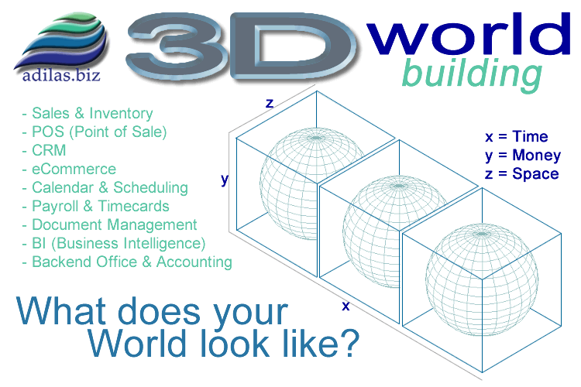
If you would like to learn more, explore the platform, participate, contribute, partner, invest, or simply follow the journey, please visit adilas.biz.

