Project 1 - Company Structure - aka The Jellyfish Model

Overview

Adilas was created and built through an independent contractor model. As the company continues to grow we see that we would benefit in our continued growth and efficiency by defining a new company structure. Our current proposal is to create an administrative advisory board made up of the Adilas team supervisors from underlying departments.

The departments are responsible for overseeing the different services and byproducts our software application has produced. Our core revenue has come from our reoccurring monthly software as a service (SaaS) structure. We have also captured a lot of other revenue from what we call our service byproducts such as consulting, training, and custom code. With more focus on company structure we will be able to better support our current client base and provide for future growth.

NOTES:

Brandon and Shannon met on 1/25/24 and decided we need to focus and refine the overviews. This is our more succinct overview above. Below our some of our notes and the original overview we wrote.

ORIGINAL OVERVIEW

Dealing with structure, what we have seen is that there needs to be a common purpose that brings us together as a company. The main thing that fuels all of the other pieces tends to be the monthly reoccurring service and/or platform. Without that common piece we would all just be a number of independents without a reason to be associated.

Because of the uniting factor of the system, it tends to create numerous byproducts that become additional services or needs for our clients. These byproducts and services span various departments. This allows us as independents to work wherever we have strengths or can fill those needs. Currently the model is very loose, but we definitely see more tightening and more structure coming into play.

Going forward we would actually like to look backwards and use some hindsight. What we have done and/or are doing we could not have done alone. Often traditional models tend to put one person in charge with others under their supervision. We, on purpose, are trying to create a multi-faceted head or advisory board. Adilas is so broad and there are so many needs that multiple people will be in charge of different areas or teams.

As we keep developing, around what is already working, our goal is to refine processes, create better checks and balances, define roles and responsibilities, and better allocate budgets and resources. As these changes come in to being we will be watching for better efficiency, defined responsibilities, management of small teams, true costing, and profit generating services.

The Adilas jellyfish model will continue to evolve. If the jellyfish concept seems too passive, it was recommended that we could think of an octopus type model. An octopus has multiple functions but is more deliberate in its decisions and movements. An octopus is also a bit more firm than a jellyfish.

We are very versatile, as a company, and we keep going day after day. We will keep working and refining it as we go. We love to help people and we love to help people succeed. We do need all of these pieces - it has to work together as a system. If you want to go fast you go alone. It you want to go far you go as a team.

Here is a link to some brainstorming related to the pieces of the jellyfish model: https://data0.adilas.biz/top_secret/time_web_gallery.cfm?corp=22&id=2284

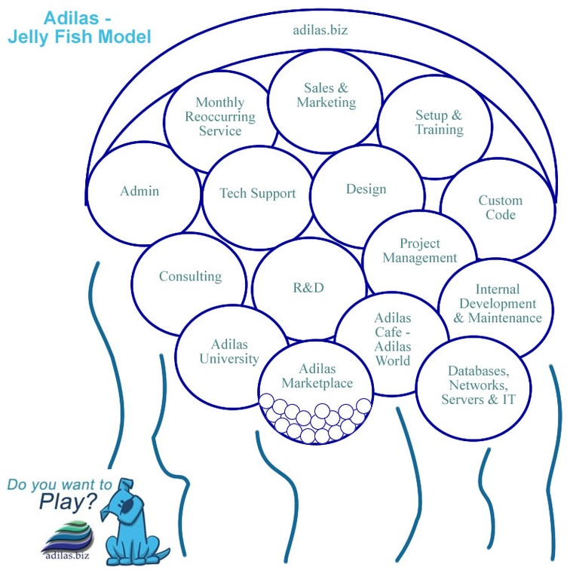

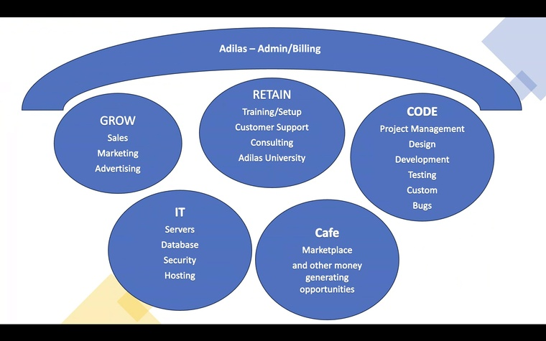

OTHER NOTES:

S.W.O.T. analysis - lots of good stuff in there looking at structure and pieces that we have spent some time on, look over some of these previous pieces

Main headings:
High-end SAAS - What byproducts and other professional services come from that offering
Divisions and Dept
Talent
Knowledge workers vs hourly workers
Personality types
Payment and compensation

We do have some stuff from Jonathon Johnson - 5 required personality types that every business should have - or the parts that need to be present/fulfilled to have a successful business

Buddy system - teams

We are really good and boot-strapping, running fairly fast and quick on things, but it is going to be important for us to be able to pick up bigger pieces.

