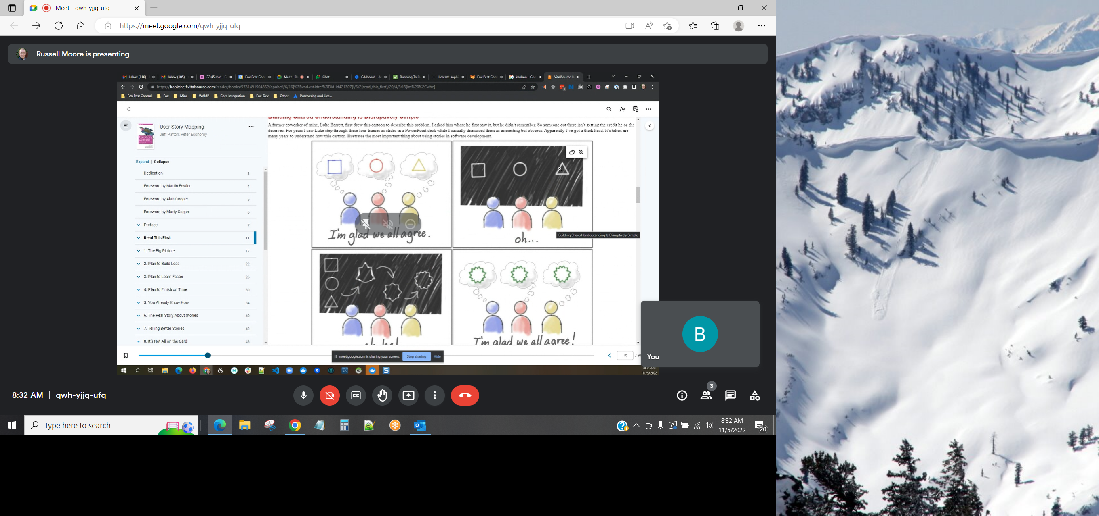
Shared understanding

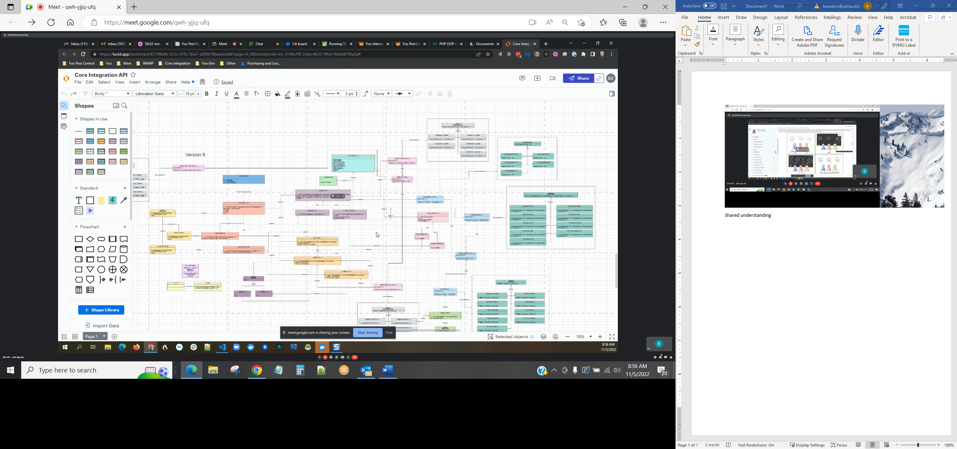
UML diagrams – unified modeling language – high level vantage point – wireframes (kind of)

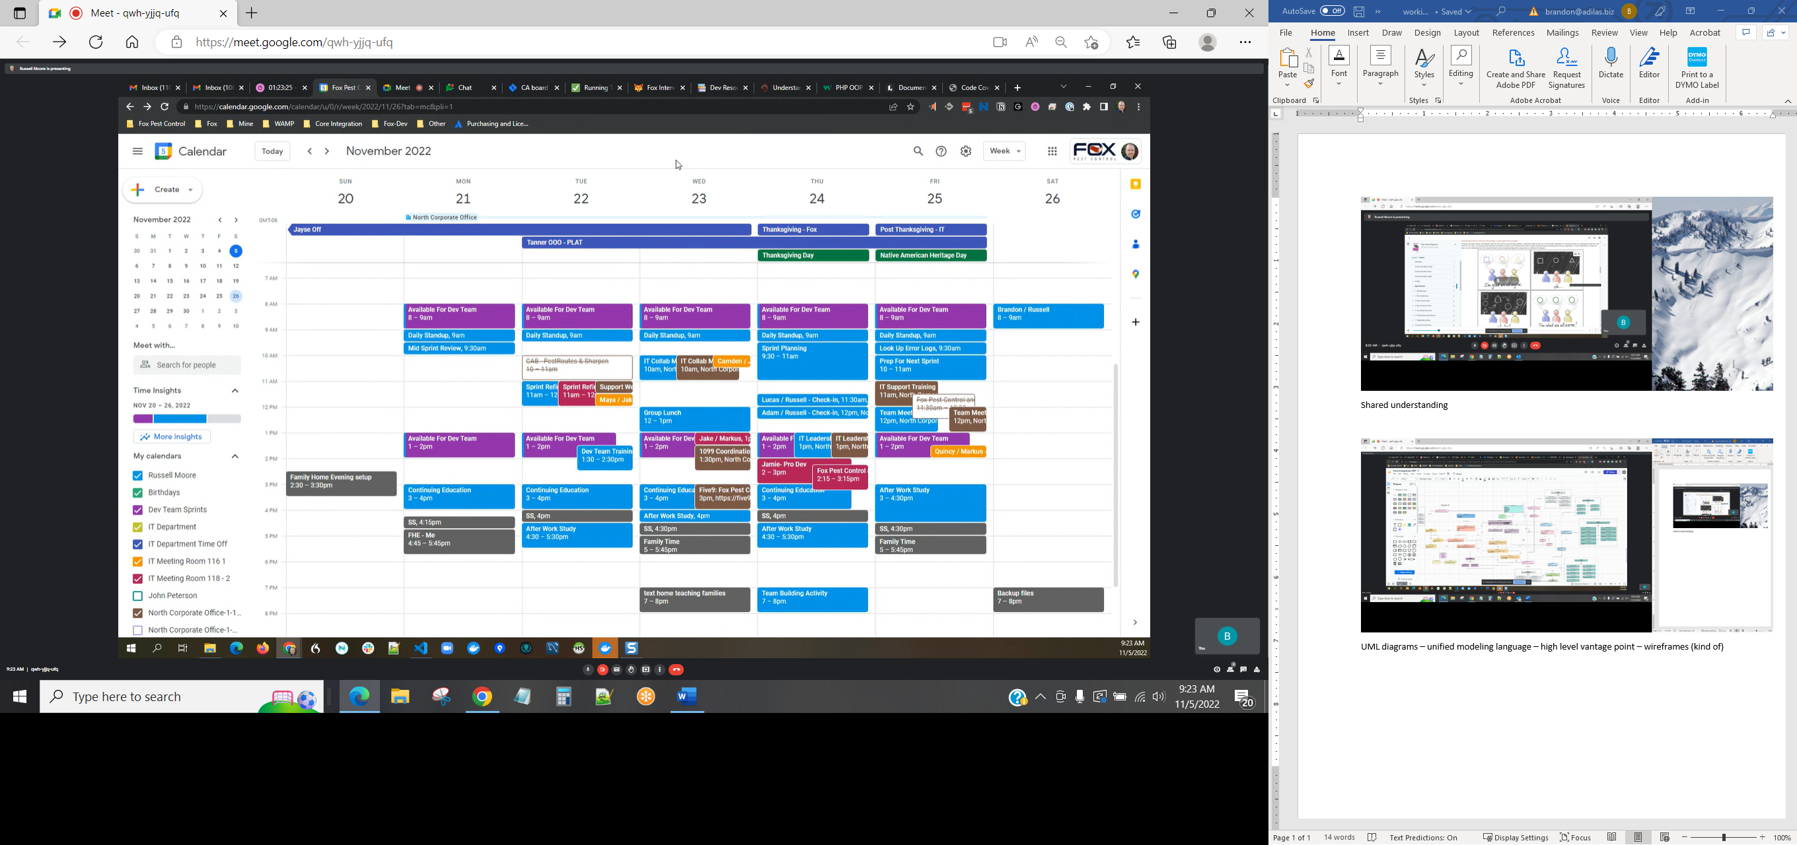
Small sample of Russell’s google calendar – just for ideas and layout

