Coldfusion Summit Notes
12/7/21

Ashley Willis – Keynote Speaker: DevRel: How we got here and where we’re going.
- History outline
- APIs: Allowing others to build on your platform yields greater use and adaptation
- Adapting to change is overwhelming (college software changes and current coding)
- Objective: build better applications faster
- Great documentation is essential
- Prioritize and act on customer feedback
- Hybrid presentation takes so much time (audio video presentation)
- Information in small blocks is where we are headed (TikTok)
- Someone is always willing to help
Charlie Arehart: Whats new in ColdFusion, Independent Consultant, CF Server Troubleshooter
- Modular function
- Cloud db connections
- 60 + new functions
- He has multiple posts with further info
- Internet issues, somewhat dry.
- More functions to do more things (functions with Java).
Nolan Erck: CFML Design Patterns and Uses
- Couldn’t see examples.
Pete Freitag: Tackling Coldfusion Security
- Good ideas
- We are implementing cfqueryparams. Implement in script (put variable in array {}.
Dave Ferguson: Relationships are not for everything
- Databases: SQL vs. NoSQL
- Educational but not much application with Adilas
Brian Klaas: Faster Apps That Won’t get crushed with queues and Pub/Sub mechanisms
- runAsynch() in CF 2018
- event driven architecture

Day Two
Jessica Keener: CSS crash course for css haters or novices
- Cool presentation forum “Mmhmm” https://www.theverge.com/2020/7/7/21314035/mmhmm-personal-video-presence-beta-phil-libin-sequoia-app
https://www.youtube.com/watch?v=c8KhKBLoSMk
- Good css intro, function, and naming
- Cascading style sheets
- Inverted Triangle CSS: broad to specific
- BEM Block|Element|Modifier
- Pre-processors?
David TAttersall: Can’t see the wood for the trees – just focus on the logs.
- More $: data monitors have become heros inside businesses.
- Cflog: text, time
- Must be scaleable
- FusionReactor: see issues graphed, see errors, search issues, alerts, dashboards
- Use fields or labels to maintain data granularity
- Define standards
- Only log what really adds value
- Retro fit logs
- Fusion-Reactor.com/beta (for those interested in trialing (Fusion-Reactor.com).
Mark Takata: Using ColdFusion with No Code
- Airtable: creates forms and APIs for the forms
- GraphiQL
- GitHub: https://github.com/MarkRTakata/
- 4. Where is this going?
- Cfmlslack
- Application: data from outside can be pulled into CF.
Brian Sappey: The Apex of Agility: Coldfusion 2021 and Automated Pipelines
- Contiuous Integration
- SSH keys?
Rey Bango: Building the next generation of secure developers
- Insecurity is a bug
- Hacking examples
- Vericode (google to go to his code)
Alishia Dvorak & Ben Vandeberg: Beyond CFPDF: Adobe APIs to supercharge your document creation and processing
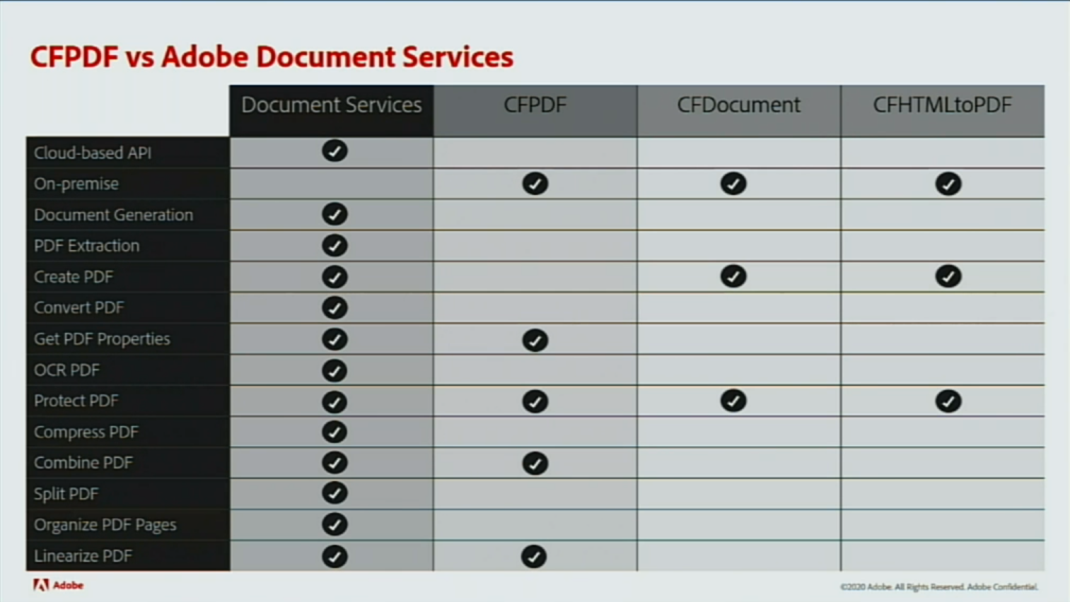
- Iframe the sign in app
- Limited programming function from programming CF. They want you to buy their product.

Mike Hartington: How you can do pixel perfect mobile development using HTML, CSS and JavaScript
- Using Angular
- Used programs, other tools (not so useful – lots of pluggins and libraries)
Matthew Clemente: Cold Brews: Getting started with Java in your ColdFusion Apps
- AWS Java SDK with ColdFusion
- Jars library to do all sorts of stuff
Mark Takata and Aditya Nema: Discussion on the future of ColdFusion
- CF more efficient: get things done more quickly (than Java)
- CF: Pull data and put it to a screen
- Direction (140 billion business - cloud?) What’s next?
- CF: not just a language – administrator, apis
- Making development easier/quicker
- CF primarily education, finance, government, commercial, HR apps, single page applications (everywhere).
- Quiet CF use: 550,000 users.
Summary:
- Great keynote on the history and need of developers/their input. (see notes)
- APIs are a big deal
- Great presentation forum “Mmhmm”
- Good CSS presentation (see notes)
- Tools for specific uses and functions
- Interesting no-program tools. What is the future
- Insecurity is a bug

