ADILAS CORE CONCEPTS - ORIGINS
Welcome, we are glad you are here! We are excited to share with you some of what we have learned along the journey. Through the process of solving our own problems we have discovered a number of core concepts and principles which have guided our direction and success.
These are the 12 core concepts we have discovered. We will dive deeper into each one of these concepts throughout this series.
- Capture & Record The Story
- Groups, Players, Individuals, & Characters
- Relationships
- Trouble, Problems, Needs, & Goals
- Decisions & Choices
- Consequences (Cause & Effects)
- Accountability
- Permissions & Settings
- Systems
- Vision & Future Developments
- Tech, Tools, & Maintenance
- Objects & Data Over Time
In our mind, no one could have really come up with all of the pieces that have created the Adilas platform on their own. We have discovered that this entire project is a conglomeration of people solving problems and needs, fostering ideas, applying concepts, and experimenting to find possible solutions. This truly has become a community effort.
Like the fable, or folk story, of the stone soup it started with a need. The story goes that some hungry strangers convinced the townspeople to contribute small amounts of food or resources to create something even better that could be enjoyed by all. The original Adilas system was a custom software write-up to solve the needs and pain points of a single business. As more and more of those needs got filled the founders and co-founders began realizing that these were problems that all businesses faced. This realization prompted them to open this custom write-up solution to other businesses for a software as a service product.
Often software as a service is very focused to a single industry or business function, but due to the diversity of the original companies that wanted to participate, it created the need to build a robust and flexible system right from the beginning. This diverse flavor has been added upon as more people and companies have contributed their ideas and resources to the project. Basically, people saw potential and started participating. This process is still going on today.
As more people became involved, the team started looking into ways of doing more education, training, and marketing. This required us to look from a higher view, work to map things out, and overall improve the user experience. As an internal team we started conducting monthly training events, both live and virtual. These training events allowed for dedicated time to develop how to share the “why” of what we are doing. We got tons of input, feedback, questions, and suggestions at these events that contributed to the project.
The next big task became trying to summarize, teach, and explain all of our code, our model, and the capability of our system. While we were swimming through this lake of information, we were exposed to this concept called, “World Building”, which completely described what we were trying to do and accomplish. Almost all of our core concepts are related to, or are stemming from, this concept of world building.
So, what is world building? And how does it relate to business software? We would like to answer this in three different ways. First, we would like to answer the question. Next, we would like to explain it a little bit further and give some examples. Lastly, we will try to explain how it has influenced our decisions and direction as a company.
1 - Answering the questions, what is world building and how does it relate to business software?
World building is the process of creating a unique environment for each business entity.
Often software tends to be built for one industry only. If you only have one industry, the whole package is built to support that business model, or world, and there is no need to diversify it. But what if the software package allowed you to diversify it to all kinds of business models and verticals. This allows you to customize the environment to meet your needs.
As you setup and create this unique environment you end up answering a number of questions. Some of these questions could be where are you located at? Does your business deal with time, products, services? Who are your customers? What do you call them? Members, clients, patients, students, etc. Basically, you are determining what you want your world to be like and what you want it to do. The system is flexible and able to handle all kind of choices and decisions. As you mix these together this is what creates the customized landing area for your data. As soon as you can start seeing that every single business is technically a different world - it starts making more sense.

2 - Explaining world building further and giving some analogies.
The author who introduced us to the concept of “World Building” was Brandon Mull, a New York Times best selling author. He was giving a presentation for young writers and artists at a university and one of the co-founders and his children happened to attend the seminar. Here is a small analogy, or example, he gave as part of his presentation.
A good science fiction author may come up with the concept of a flying car. But a really good science fiction author thinks at the level of world building. What are the causes and effects that occur with having a flying car? What is the technology that allows that? What are the traffic laws? What things keep it in check? What happens if there is a traffic jam? A wreck? How are they powered? How are they stored? How are they fixed? What are their speeds, capabilities? Are they armed? Etc., etc., etc.
Think of your favorite movie or book. Think of some of the different things that make up the environment and what makes it unique and special? Some of the best books take a user and they physically create an environment, a world, that is rich ….., who do they interact with, what do they need to do, what are the things that make up their “world”?
General World Building
- Where is your world located?
- What special features does your world have?
- What does your world have an abundance of?
- What does it have a lack of?
- Who is on your world? Different civilizations? Friends? Enemies?
- How diversified are the civilizations or the areas?
- What are the reasons they are separated or diversified?
- Who are the characters and the groups?
- How will they interact with each other?
- What kind of things are they trying to overcome or accomplish?
Business World Building
- Where is your business located?
- What do you call your business?
- What do you call your products or services?
- What do you call the people you interact with in your business?
- Who do call the people who work for you and work with you?
- Who are the people that buy your services or products?
- Do you sell services, products, large items, etc?
- How do you distribute what you are selling? In-person, online, call-in, delivery, etc.
- Do you have a special flow or processes in your business world?
- How do things in your business operate and work?
We have a core package that is flexible and customizable on the outset.

This concept is heavily used by authors in books and movies to virtually transport their audience into these virtual worlds or stories. We could see so many parallels in world building to what we were already doing in Adilas, we just didn’t have a name for it.

3 - how it ties in and has influenced us to go in certain directions
We have created a systematized approach. Instead of having 4-10 software packages to run your system and capture all of your data - you can have 1 system that you can customize and setup to virtually simulate your exact world and capture the processes from beginning to end. This allows you the incredible ability and flexibility to work within one system and not run into the dead ends of marrying different systems that don’t talk to each other.
Once a world is setup and created you then have to set up the rest of the supporting infrastructure to maintain that special environment. This environment could be dealing with location, stores, departments, jobs, projects, etc.; who you are interacting with such as students, members, clients, patients, etc.; are we selling products, services, etc.; is there special verbage that we use, naming, language, nomenclature, etc.

________________________________________________

That section below was from an email from Marisa - dealing with some marketing stuff.
I really like Adi = All Data Is...
This concept will allow the customer to determine what Adi is to them, just like they do with their data. If we think about dogs in general, each of them has its own personality. Circling back to what Brandon has said many times, Adilas is a 3D world-building concept. Each business can pick and choose how they want to build that world. Considering that Adi is our avatar and represents Adilas, I think we could go the same route for Adi. They can pick and choose the most important characteristic that Adi has based on their needs. Do they need her to Search? Do they need her to Retrieve? Do they need her to be User Friendly? Their data can be and do whatever they need it to. Maybe that's how we need to portray Adi too.
Adi = All Data is..."customizable and trainable"
Adi = All Data is..."trustworthy and loyal"
Adi = All Data is... "whatever you need it to be"
The list goes on and on :)
Intellectual
When we were dealing with Bridgerland - they have all these different worlds all under one college/universe, but they all need their own rules, language, and things to play by … Just like our world
Sci-fi car anology from Brandon Mull
https://data0.adilas.biz/top_secret/time_web_gallery.cfm?corp=22&id=866 - things that we want to protect and expand upon... intellectual property stuff
From Shannon - I really think we need to spend some time explaining world building because that is truly the foundation for the core concepts - every single one of them is related to that
We even summarized our core concepts or grouped them - 1-6 pieces of world building, 7-12 how we maintain/maintenance, keep our virtual worlds rotating
I don’t think the world has realized that they can use these concepts in the business world - Brandon predicts they will realize the value and power of this and will adopt this into the business world
Levels of world building - graphic - Universe, Galaxy, Cluster, Solar Systems, World, Locations, Groups, Individual Data/Items, Run the whole thing over time….
As the internal team was expanding their vision it just kept growing and growing
Trying to map out how all of these pieces interacted together really allowed us to see that we had all of the essential pieces contained in one system! realized that being a gave us the ability and power to do things that others can’t because
The next phase of development pushed us toward more education, training, and marketing.
helped us to see how much power was contained in every piece being
The concepts of a system and being able to interact
WORKING HERE - RIGHT ABOVE

in Adilas and trying to teach . Since then we have adopted the concepts of world building as the core concepts that underly the power of Adilas.

That effort of trying to boil things down and map pieces out helped with both expanding our vision and
In 2013 we began taking steps to provide more training and education tools as well as create some sales and marketing pieces. While working on an infographic for this purpose called the Adilas formula, we were able to determine we had 12 main tool sets, or application players, we use to accomplish all of our business functions within Adilas. We were also able to organize our business functions into 12 main categories. With 12 seeming to be the magic number we really wanted to condense our concepts into 12 core concepts. This took a great deal of effort to boil down so many of the concepts we have identified and value in Adilas.
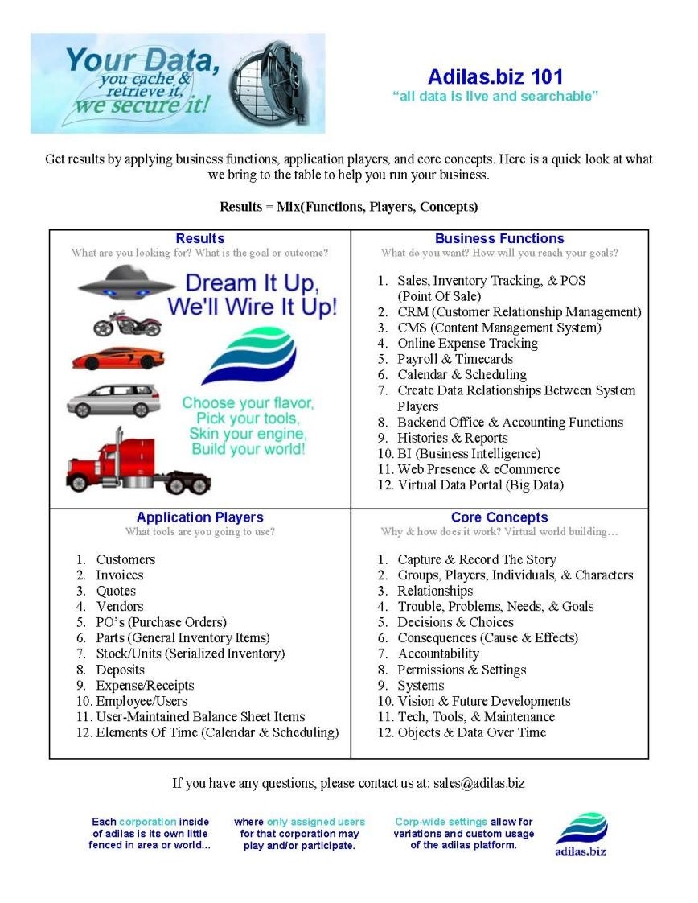
As a company we realized that we really needed to teach people about the concepts so that they could be empowered to make the system work for them fully.
We also felt that we could group our main business functions into 12 categories.
We wanted to include some of the Adilas core concepts on this same infographic but had a big challenge with how many concepts we could identify that we used in Adilas. We really had to boil these concepts down and ca
Part of our discoveries we ended up finding 12 main application players. and then we worked to narrow down a list of 12 main business functions we accomplish.

Application Players
What tools are you going to use?
1. Customers
2. Invoices
3. Quotes
4. Vendors
5. PO’s (Purchase Orders)
6. Parts (General Inventory Items)
7. Stock/Units (Serialized Inventory)
8. Deposits
9. Expense/Receipts
10. Employee/Users
11. User-Maintained Balance Sheet Items
12. Elements Of Time (Calendar & Scheduling)

Business Functions
What do you want? How will you reach your goals?
1. Sales, Inventory Tracking, & POS (Point Of Sale)
2. CRM (Customer Relationship Management)
3. CMS (Content Management System)
4. Online Expense Tracking
5. Payroll & Timecards
6. Calendar & Scheduling
7. Create Data Relationships Between System Players
8. Backend Office & Accounting Functions
9. Histories & Reports
10. BI (Business Intelligence)
11. Web Presence & eCommerce
12. Virtual Data Portal (Big Data)

Protect through sharing…..
World Building ….
Teach, navigate, and began to map out the system - 2010 & then hearing an author explain what they do for books and movies - this helped us because we are trying to do that same thing….
The mantra became, “What is the next step? How do we get there? Who is going to pay for it? And who else is going to use this?” These questions allowed us to expand our mind and look beyond our own needs. We had to make things versatile for the multiple companies and business verticals. Through the process of developing that
As that process developed some inside jokes ended up being, “You can do that? (Question mark???) Yes! You can do that! (Exclamation mark!!!)”
Our process of discovery continued by trying to capture all of the daily operations of the companies we were trying to serve. Imagine tracking every penny in and every penny out through all of the twists and turns it takes, and eventually it’s entire life cycle.
Teach, navigate, and began to map out the system - 2010 & then hearing an author explain what they do for books and movies - this helped us because we are trying to do that same thing….

Welcome - come in and see
community based project
lay a foundation to build on
Natural cause & effect of what started to happen - how we discovered
like growing a garden - idea farm
expectations
This is our own world building story
idea farm
stone soup - people have paid for the value they see

https://data0.adilas.biz/top_secret/time_web_gallery.cfm?corp=371&id=2774 - protecting the core concepts by sharing

https://data0.adilas.biz/top_secret/time_web_gallery.cfm?corp=371&id=3681 - huge brainstorming session (from a training event) dealing with the core concepts
https://data0.adilas.biz/top_secret/time_web_gallery.cfm?corp=371&id=2279 - brainstorming on core concepts

https://data0.adilas.biz/top_secret/time_web_gallery.cfm?corp=371&id=2278 - some analogies about concepts

https://data0.adilas.biz/top_secret/time_web_gallery.cfm?corp=371&id=3627 - trying to draw and illustrate some of the concepts

0untn900gvccccccc
+hjki

