ADILAS CORE CONCEPTS - ORIGINS
Welcome, we are glad you are here! We are excited to share with you some of what we have learned along the journey. Through the process of solving our own problems we have discovered a number of core concepts and principles which have guided our direction and success.
These are the 12 core concepts we have discovered. We will dive deeper into each one of these concepts throughout this series.
- Capture & Record The Story
- Groups, Players, Individuals, & Characters
- Relationships
- Trouble, Problems, Needs, & Goals
- Decisions & Choices
- Consequences (Cause & Effects)
- Accountability
- Permissions & Settings
- Systems
- Vision & Future Developments
- Tech, Tools, & Maintenance
- Objects & Data Over Time
In our mind, no one could have really come up with all of the pieces that have created the Adilas platform on their own. We have discovered that this entire project is a conglomeration of people solving problems and needs, fostering ideas, applying concepts, and experimenting to find possible solutions. This truly has become a community effort.
Like the fable, or folk story, of the stone soup it started with a need. The story goes that some hungry strangers convinced the townspeople to contribute small amounts of food or resources to create something even better that could be enjoyed by all. The original Adilas system was a custom software write-up to solve the needs and pain points of a single business. As more and more of those needs got filled the founders and co-founders began realizing that these were problems that all businesses faced. This realization prompted them to open this custom write-up solution to other businesses for a software as a service product.
Often software as a service is very focused to a single industry or business function, but due to the diversity of the original companies that wanted to participate, it created the need to build a robust and flexible system right from the beginning. This diverse flavor has been added upon as more people and companies have contributed their ideas and resources to the project. Being able to see this potential, or the next possible steps, prompted people to input their ideas and resources to help build the next levels. This process is still going on today.
The next phase of development pushed us toward more education, training, and marketing. As our focus was centered on these pieces we were introduced to a concept called, “World Building”, at a young writer and artist festival. This concept is heavily used by authors in books and movies to virtually transport their audience into these virtual worlds or stories. We could see so many parallels in world building to what we were already doing in Adilas, we just didn’t have a name for it. Having more language …..WORKING HERE….. on these concepts helped us focus even more on the power of world building in accomplishing people’s business goals, dreams, and objectives.
WORKING HERE - RIGHT ABOVE

in Adilas and trying to teach . Since then we have adopted the concepts of world building as the core concepts that underly the power of Adilas.

That effort of trying to boil things down and map pieces out helped with both expanding our vision and
In 2013 we began taking steps to provide more training and education tools as well as create some sales and marketing pieces. While working on an infographic for this purpose called the Adilas formula, we were able to determine we had 12 main tool sets, or application players, we use to accomplish all of our business functions within Adilas. We were also able to organize our business functions into 12 main categories. With 12 seeming to be the magic number we really wanted to condense our concepts into 12 core concepts. This took a great deal of effort to boil down so many of the concepts we have identified and value in Adilas.
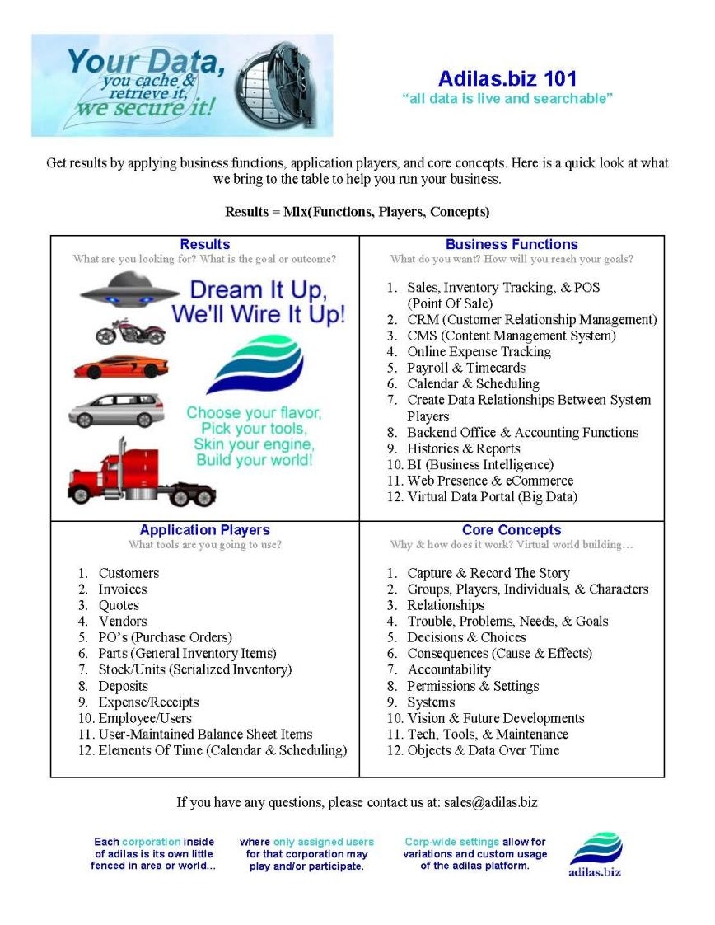
As a company we realized that we really needed to teach people about the concepts so that they could be empowered to make the system work for them fully.
We also felt that we could group our main business functions into 12 categories.
We wanted to include some of the Adilas core concepts on this same infographic but had a big challenge with how many concepts we could identify that we used in Adilas. We really had to boil these concepts down and ca
Part of our discoveries we ended up finding 12 main application players. and then we worked to narrow down a list of 12 main business functions we accomplish.

Application Players
What tools are you going to use?
1. Customers
2. Invoices
3. Quotes
4. Vendors
5. PO’s (Purchase Orders)
6. Parts (General Inventory Items)
7. Stock/Units (Serialized Inventory)
8. Deposits
9. Expense/Receipts
10. Employee/Users
11. User-Maintained Balance Sheet Items
12. Elements Of Time (Calendar & Scheduling)

Business Functions
What do you want? How will you reach your goals?
1. Sales, Inventory Tracking, & POS (Point Of Sale)
2. CRM (Customer Relationship Management)
3. CMS (Content Management System)
4. Online Expense Tracking
5. Payroll & Timecards
6. Calendar & Scheduling
7. Create Data Relationships Between System Players
8. Backend Office & Accounting Functions
9. Histories & Reports
10. BI (Business Intelligence)
11. Web Presence & eCommerce
12. Virtual Data Portal (Big Data)

Protect through sharing…..
World Building ….
Teach, navigate, and began to map out the system - 2010 & then hearing an author explain what they do for books and movies - this helped us because we are trying to do that same thing….
The mantra became, “What is the next step? How do we get there? Who is going to pay for it? And who else is going to use this?” These questions allowed us to expand our mind and look beyond our own needs. We had to make things versatile for the multiple companies and business verticals. Through the process of developing that
As that process developed some inside jokes ended up being, “You can do that? (Question mark???) Yes! You can do that! (Exclamation mark!!!)”
Our process of discovery continued by trying to capture all of the daily operations of the companies we were trying to serve. Imagine tracking every penny in and every penny out through all of the twists and turns it takes, and eventually it’s entire life cycle.
Teach, navigate, and began to map out the system - 2010 & then hearing an author explain what they do for books and movies - this helped us because we are trying to do that same thing….

Welcome - come in and see
community based project
lay a foundation to build on
Natural cause & effect of what started to happen - how we discovered
like growing a garden - idea farm
expectations
This is our own world building story
idea farm
stone soup - people have paid for the value they see

https://data0.adilas.biz/top_secret/time_web_gallery.cfm?corp=371&id=2774 - protecting the core concepts by sharing

https://data0.adilas.biz/top_secret/time_web_gallery.cfm?corp=371&id=3681 - huge brainstorming session (from a training event) dealing with the core concepts
https://data0.adilas.biz/top_secret/time_web_gallery.cfm?corp=371&id=2279 - brainstorming on core concepts

https://data0.adilas.biz/top_secret/time_web_gallery.cfm?corp=371&id=2278 - some analogies about concepts

https://data0.adilas.biz/top_secret/time_web_gallery.cfm?corp=371&id=3627 - trying to draw and illustrate some of the concepts

0untn900gvccccccc
+hjki

