Future Adilas Business Model Planning – Where are we headed?
Steve has had the idea of putting Adilas into a trust for many years. We would like to advance that ball forward. We are interested in hearing some of your ideas and input on creating a plan for moving in that direction.

- How big do we want to get?
- What is our time frame to get there?
- What do we want to do/have for our company/user culture?
- What are some of the things you like about what we are doing right now?
- What are some things you would want us to change?
- As far as structure, what do you like? Do you like the independent model or would you like it more solid?

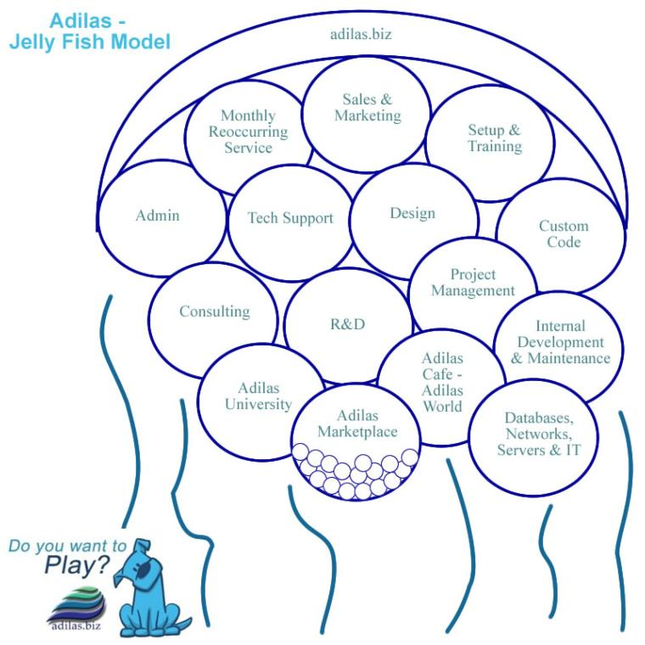
- Do you like the jellyfish model? (Organized with a loose, flowing feeling. Adilas is the overarching umbrella and there are a number of sub departments or subsets.)

- Would you want to see something different (company structure)?
- What products and services do you think we should focus on?
- Do we want to continue to internally fund this or seek outside investments?
- What do we need on the management side? What do we need in leaders and managers? Traditional managers? Or more of a Board of Trustees or Advisors?

- Do we want some sort of internal loyalty system or revenue sharing plan?

- How do you play? What is your time commitment, scheduling, maxes and mins (hours per week/month)?

- What business verticals are you interested in?

- Where would you like to focus?

- What are your thoughts on look and feel for the application interface?

- Let’s talk pricing. What are your thoughts?

- What about marketing and sales?

- What about code, databases, automation, testing, deployment, and other techy stuff? Back-ups, redundancy, mirrors, servers, clusters, etc.

- What are your thoughts on education, training, and add-on services?

- What about custom and API sockets and integrating with other external products?

- If we do a trust what are the other rules or parameters we want to set up? Is it just time, is it time and money, is it investment, what is necessary if you want to buy in? How do we determine who is active and not active? How many virtual family members do we want? Etc.

- Where do you see us (as a company) in 1 year, 5 years, 10 years?

- Where do you want to be in 1 year, 5 years, 10 years?

- Other ideas and thoughts?

