Future Adilas Business Model Planning – Where are we headed?
Steve has had the idea of putting Adilas into a trust for many years. We would like to advance that ball forward. We are interested in hearing some of your ideas and input on creating a plan for moving in that direction.

- How big do we want to get?
I see adilas as a medium to large-sized company with a “small to medium” company mindset, keeping the best interest of all those involved at the forefront of the decision making processes. The places where I think we could expand and get a tad larger would be in customer service and tech support.
- What is our time frame to get there?
I’d say between 2-3 years?
- What do we want to do/have for our company/user culture?
Pretty much what it is now. A culture where those involved make decisions and work together for the common good of everyone, including the customers. Where we don’t feel pressure to conform or do things a certain way but have space to freely create and transform our own thoughts, ideas, and processes into a collective pool of greatness and creativity.
- What are some of the things you like about what we are doing right now?
Exactly what I stated above.
- What are some things you would want us to change?
I think by doing this right here, asking for everyone’s input on how to structure the company for all those involved may be the change we need. We all just need to come together and get on the same page of what vertices to take on next and map out how we get there successfully. This product has the ability to change many industries and if we can focus our time and energy into one or many vertices based on groups of individuals who have experience in each of those fields, I think we can go very far.
- As far as structure, what do you like? Do you like the independent model or would you like it more solid?
Personally, I am a fan of the independent model. Being able to choose my own direction with my own abilities and have a flexible schedule of being an independent contractor is exactly what I think makes adilas so unique and attractive.

However, I can see how this could be one of our downfalls, as it allows certain people to come and go as they please. I know it would be nice to have certain dedicated people that always handle certain aspects in a timely manner. I will admit fault here in the marketing realm...as an independent contractor, it’s easy to say “because I’m not employed by this company, I have the freedom to work whenever I please and if I don’t get to that right away, it’s no big deal.” And I know that, personally, if I had a little more structure/pressure on me from a “boss” I would perform some duties much quicker and maintain a sense of being “needed” or “essential” to the company.
With that being said, I still think we should maintain the independent model yet put in place a more solid plan/structure to encourage everyone to keep on track with their responsibilities as it benefits all involved. Myself included :)
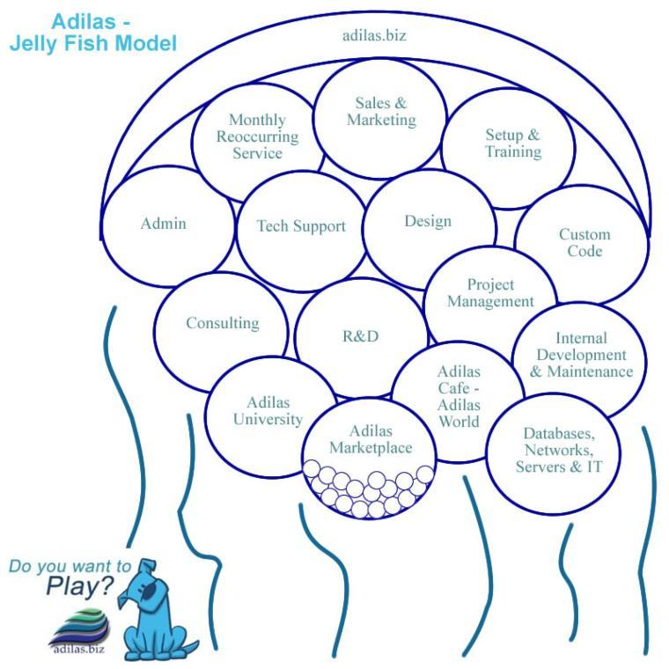
- Do you like the jellyfish model? (Organized with a loose, flowing feeling. Adilas is the overarching umbrella and there are a number of sub departments or subsets.)
Yes, I love this model. Especially because it doesn’t feel like one department is better/more important than any other. It takes a collective effort of all departments to made adilas succeed.
- Would you want to see something different (company structure)?
As I stated above, I think the only thing we might want to consider is a more solid and definitive plan, along with designated roles for each individual. I think what we are doing here is a great first step towards that.
- What products and services do you think we should focus on?
I am thrilled that a lot of our focus is heading towards WanderWays. Charles and I have put a lot of time and effort into this verticle and I cannot wait to see how it progresses. I believe this is the next upcoming industry to jump into while the market is heating up in the RV/camping world.
There is an absolute need for a custom reservation tool and if we can create one that encompasses everything adilas already has to offer with accounting, time management, payroll and more…..this is going to give us a GIANT advantage in this industry.
- Do we want to continue to internally fund this or seek outside investments?
This is a double edge sword type of question so I will answer with what I see as pros and cons of both :)
Internally funded PROS =
- ability to customize the product/services how WE see fit
- no outside pressure to “conform” a certain way or develop something that doesn’t coincide with our internal business model/plans
- more control over our own desires for verticals that we feel are needed
Internally funded CONS =
- less opportunity for growth and development with limited access to funds
- puts most people on a limited hourly tracking system instead of allowing all to produce as much as possible for the greater good of the company (again, just due to lack of funds) therefore making it hard to make ends meet for their families and lifestyle.
Outside Investment PROS =
- gaining access to more funds in order to produce quality products for the customers and allow ourselves the ability to make enough money to support our families
- would possibility give adilas more funds to obtain greater resources such as customer support center, marketing funds and more
- allows collaborative efforts from outside of adilas which would help bring in new perspectives from different industries
Outside Investment CONS =
- less control of our products and services if we gain an investor who feels the need to take over the project and do it “their way or the highway”
- the interest that adilas may be required to pay back over the life of the investment
- communication between all involved must absolutely be key in order to succeed, and that can be difficult when visions and ideas clash

- What do we need on the management side? What do we need in leaders and managers? Traditional managers? Or more of a Board of Trustees or Advisors?
I think a Board of Trustees would be a great fit for the adilas business model. A group of people who have the knowledge and collective understanding of the best interests of everyone involved, including our customers.
- Do we want some sort of internal loyalty system or revenue sharing plan?
My knowledge in this aspect is limited and to comfortably answer this question, I would need to do a bit more research on this topic.
- How do you play? What is your time commitment, scheduling, maxes and mins (hours per week/month)?
My goal from the very beginning of working with adilas was to make this my full time job. I believe in the product and the company with all my heart. But currently, since funds tight for my family, my need for other commitments has me working at this part-time. Ideally, I would love to commit 40+ hours/week with adilas...primarily WanderWays is my goal. Once that vertical is built and ready to go, it is my dream to continue to enhance the product and take it to market by being a full-time traveling saleswoman for WanderWays
- What business verticals are you interested in?
Well, I think I made this clear in my above statement :)

- Where would you like to focus?
WanderWays!!

- What are your thoughts on look and feel for the application interface?
When I first joined adilas a couple years ago, my honest thoughts were that it obviously had great functionality and a plethora of tools for almost any business owner, but even I struggled to navigate the system and learn it to a degree of being able to run my own business (and I consider myself a pretty techy person). HOWEVER, the improvements that have been made over the last 6 months are a giant leap towards better UI and functionality. I am thrilled that adilas is working towards a sleeker, more modern interface that will allow a person with any skill level to be able to navigate the system more efficiently. Keep up the great work!!
- Let’s talk pricing. What are your thoughts?
I am going to echo something that was said in the meeting this morning…
While I feel like our prices are very reasonable compared to other SaaS, I also feel that we cannot provide the support and development that our bigger clients crave and need with our current pricing. If we were to up our prices and generate more income, adilas may be able to provide the support and development needed to take care of those clients.
- What about marketing and sales?
Speaking from the marketing side...this is where I feel adilas lacks the most. I love dreaming up ideas for marketing and putting my dreams into the videos and flyers, but we need more structure and guidance here as to what the overall objective is for the company as a whole.
It would be nice to have a finalized marketing structure where we fully outline our marketing goals and where we would like to put our efforts. Some questions that need to be answered are…
- How do we increase brand awareness? Through social media, online advertising or some other platform?
- How do we generate an increase of quality leads?
- How do we attribute our marketing activities to revenue generation?
- How do we increase brand engagement? How do we get people to spread the word about adilas for us?
- What business objectives does the marketing strategy need to support? Increase revenue? Maintain profit margin? Etc.
- What about code, databases, automation, testing, deployment, and other techy stuff? Back-ups, redundancy, mirrors, servers, clusters, etc.
Again, this is one of those areas and I differ to others who are more knowledgeable.
- What are your thoughts on education, training, and add-on services?
I think it would be beneficial to have more education and training videos for almost every aspect of the system. I know this would take quite some time to produce and would require a constant amount of updates, but if customers could quickly gain access to instructional tools, it would cut back on the need for them to call into customer support.

Also, a monthly online training would be a great idea. Once a month we take a poll from the users as to what they would like to learn the following month. This would allow the users to decide what they determine is needed to to brush up on their skills.

- What about custom and API sockets and integrating with other external products?
I’m not too familiar with this topic either. The only feedback I have on this is what knowledge I have gained from working with Chuck and the fact that quite a bit of additional features can be run through API, therefore, I would think this would be a good thing?

- If we do a trust what are the other rules or parameters we want to set up? Is it just time, is it time and money, is it investment, what is necessary if you want to buy in? How do we determine who is active and not active? How many virtual family members do we want? Etc.

- Where do you see us (as a company) in 1 year, 5 years, 10 years?
In 5 years, I see adilas being slightly larger than what we are and to have a couple more vertices to bring in funds. I see WanderWays as being one of those verticals that will assist with this.

- Where do you want to be in 1 year, 5 years, 10 years?
In 1 year, I would love to have WanderWays ready to launch and start selling it to campgrounds/rv parks. Once this product is ready to take to market, within 5 years I would love to be on the road traveling selling the product and continually improving on it. And in 10 years, I would love to have that built up so that I can have multiple people below me selling the product and maintaining it, helping others to make a living doing what I love.

- Other ideas and thoughts?
I just want to commend everyone involved in adilas for making this one of the best companies I’ve ever had the pleasure to work with. The adilas team is comprised of some of the most creative and innovative individuals. We all keep each other motivated and the words of encouragement and helpfulness that we receive from one another is very special. Thank you to everyone who has made me feel like part of the family.

Let’s keep up the great work and move onward and upward!

