Future Adilas Business Model Planning – Where are we headed?
Steve has had the idea of putting Adilas into a trust for many years. We would like to advance that ball forward. We are interested in hearing some of your ideas and input on creating a plan for moving in that direction.

- How big do we want to get?
(Funny when I read this I was thinking about the software and database functionality and not about the size of organization aka people.) As for group of people I think as small as we can be. If we can work together, communicate effectively and be organized we can get a lot done.

- What is our time frame to get there?

I think this is what made me think size of product not people. As far as people go I think we are pretty close to being there, with the exception of needing a Wayne sub, and possibly another consultant.

- What do we want to do/have for our company/user culture?
Laid back culture like we currently have.
- What are some of the things you like about what we are doing right now?
-The oversight and added testing before adding code to the database is making a big difference.
-Working on a phone tree to better help our clients and use the limit resources we have in a more directed manner.
- What are some things you would want us to change?
I like the idea of adding training/service inside of Adilas. I think that is the only way to really start helping our existing clients and make sure they aren’t slipping through the cracks. Moving forward with new clients, I like the idea of working as a team to train and support. *We do need to raise our rates or figure out a way to charge for this service though as Adilas can’t afford to pay for this.
- As far as structure, what do you like? Do you like the independent model or would you like it more solid?
I think a hybrid could be good. I like being independent and also working inside. This may not work for everyone but it works for me. Variety and change are what keep me excited about my work.
*I was working with a client (not my client, just a client) and I was able to help them really understand what was going on in their system and how to fix it. Helping people is my favorite part of this work, and I don’t want to give up consulting. But most of my clients don’t really need me that much as they are already trained, so I want to be able to train others, possibly from within Adilas. I like the idea of commission sharing for this reason. A team taking care of clients makes sure they are super taken care of. I don’t think people would mind paying for this service/support if they knew about it and had the option up front.

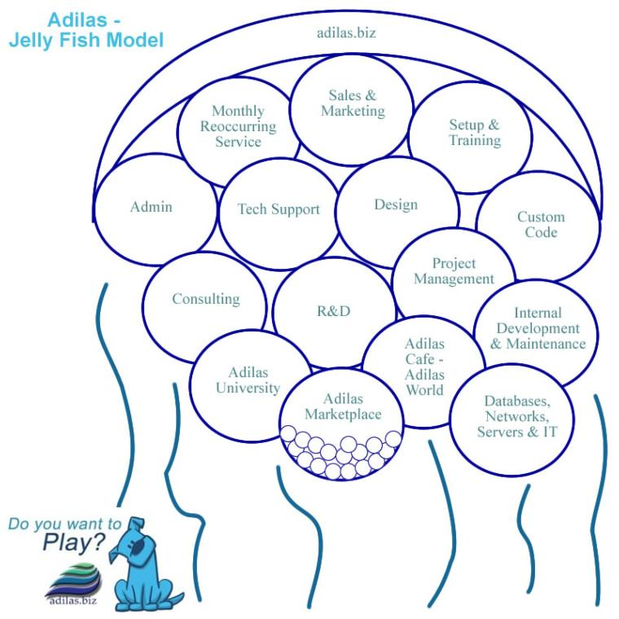
- Do you like the jellyfish model? (Organized with a loose, flowing feeling. Adilas is the overarching umbrella and there are a number of sub departments or subsets.)

- Would you want to see something different (company structure)?
Possibly, but I don’t like the idea of bureaucracy and I don’t think this group is into that.
- What products and services do you think we should focus on?
-Customer training (new and existing)
-Streamlining e-commerce- making it more intuitive for all industries (it’s the present and the future)

- Do we want to continue to internally fund this or seek outside investments?
Debt is a burden that I know Steve won’t agree to and I think if we grow in a smart direction we can avoid it.
- What do we need on the management side? What do we need in leaders and managers? Traditional managers? Or more of a Board of Trustees or Advisors?

- Do we want some sort of internal loyalty system or revenue sharing plan?

Sounds interesting

- How do you play? What is your time commitment, scheduling, maxes and mins (hours per week/month)?
Currently I’m averaging around 30hrs a week. I could definitely work more but that is how long it has been taking me to accomplish what I need to every week.

- What business verticals are you interested in?
All

- Where would you like to focus?
All

- What are your thoughts on look and feel for the application interface?
I think it could be more contemporary. I know it is hard to build to that, as the minute you get up to date there is a new look. I’m no fashionista but I would say our shopping cart could use a skin, which I know is on the radar.

- Let’s talk pricing. What are your thoughts? Some kind of raise in price for new servers as of 1/1/2021.
-I think for new accounts we could go up $50/month in cannabis for sure (to help cover METRC overhead)
-New accounts non-cannabis= raise slightly as of Jan 1, 2021?
-Existing accounts- cannabis= $20/month to deal with all the 3rd party connections?
-Existing accounts non-cannabis= $10/month for new servers?
-Charge for 3rd party connections- charge client or 3rd party

- What about marketing and sales?
Definitely need more sales

- What about code, databases, automation, testing, deployment, and other techy stuff? Back-ups, redundancy, mirrors, servers, clusters, etc.
I second Wayne’s “Yes to all of it!”

- What are your thoughts on education, training, and add-on services?
I think we can raise our image with more of this.

- What about custom and API sockets and integrating with other external products?
Pain in the butt- let’s build it internally!

- If we do a trust what are the other rules or parameters we want to set up? Is it just time, is it time and money, is it investment, what is necessary if you want to buy in? How do we determine who is active and not active? How many virtual family members do we want? Etc.
I think anyone who consistently invests time (TBD) can be in. Would need to set up parameters ie different levels based on how much time you have already put in.

- Where do you see us (as a company) in 1 year, 5 years, 10 years?
Continue to grow the platform. More contemporary look and feel.

- Where do you want to be in 1 year, 5 years, 10 years?
Working with Adilas and helping clients learn how to run their systems/setup their systems.
Working to help the development of the software in a useful, meaningful direction.
Making more money

- Other ideas and thoughts?
Thanks for doing this. It is super valuable and important that everyone is giving input to all of these thoughts, directions, ideas.

