Future Adilas Business Model Planning – Where are we headed ?
Bryan’s Input

Steve has had the idea of putting Adilas into a trust for many years. We would like to advance that ball forward. We are interested in hearing some of your ideas and input on creating a plan for moving in that direction.
- How big do we want to get?
  - We want to provide the best service to as many people as possible.
  - If we have a great model it can serve everyone.

- What is our time frame to get there?
  - Grow naturally and fiscally conservative.

- What do we want to do/have for our company/user culture?
  - I like the company culture:
    - Easy access to staff assistance (If I need to contact any of the staff, I can).
    - Knowledgeable and helpful staff.
    - Opportunities for input (like this one).

- What are some of the things you like about what we are doing right now?
  - Increasing expertise and education (for example: Russ, Alan, Wayne etc).
  - Clearer organization (Cory/planning/charging for work).

- What are some things you would want us to change?
  - ?

- As far as structure, what do you like? Do you like the independent model or would you like it more solid?
  - We seem to be moving in the right direction.

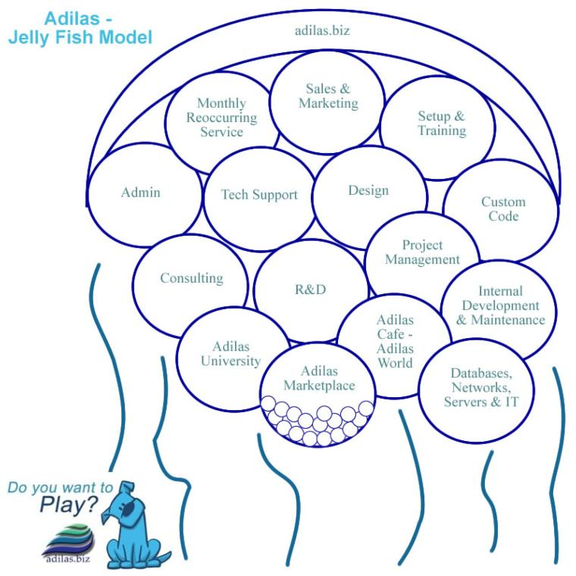
- Do you like the jellyfish model? (Organized with a loose, flowing feeling. Adilas is the overarching umbrella and there are a number of sub departments or subsets.)
  - It works for now until we find something better.

- Would you want to see something different (company structure)?
  - I think that the current structure is working.

- What products and services do you think we should focus on?
  - I like the way Adilas lets the clients decide what we focus on by them funding development.

- Do we want to continue to internally fund this or seek outside investments?
  - Primarily internal funding.

- What do we need on the management side? What do we need in leaders and managers? Traditional managers? Or more of a Board of Trustees or Advisors?
  - I think what we have works.

- Do we want some sort of internal loyalty system or revenue sharing plan?
  - This would be great! Steve and Brandon have been very generous in the past, and I have appreciated these benefits (with the server setup benefit).

- How do you play? What is your time commitment, scheduling, maxes and mins (hours per week/month)?
  - I have played full time 30-40+ hrs per week.

- What business verticals are you interested in?
  - I have done and currently am involved in programming, project management, research and development, tech support, and consulting.

- Where would you like to focus?
  - Continuing work in programming, project management, research and development, tech support, consulting.
  - I am interested in expanding and learning new skills as opportunities present themselves.

- What are your thoughts on look and feel for the application interface?
  - Adilas has been actively engaged in making improvements (Russ’ and Charles work for example).

- Let’s talk pricing. What are your thoughts?
  - What do Steve and Brandon think?
    - Researching other competitors would seem to be useful. I think Steve and Brandon have a good handle on this.

- What about marketing and sales?
  - I like what Steve has been doing - stepping out and working on sales.

- What about code, databases, automation, testing, deployment, and other techy stuff? Back-ups, redundancy, mirrors, servers, clusters, etc.
  - I like working with people that have expertise and are interested in these things (Wayne and others).
  - I like that I have had some experience in this (server setup).

- What are your thoughts on education, training, and add-on services?
  - It has been a good experience.
    - Adilas training has benefitted my Adilas knowledge and relationships with staff/clients (Colorado, Cache Valley and in house training).
    - Brandon’s training has been invaluable and allowed me to know and do what I do now.

- What about custom and API sockets and integrating with other external products?
  - They seem to be increasingly in demand. I like the model that we build them as there is outside demand and money.

- If we do a trust what are the other rules or parameters we want to set up? Is it just time, is it time and money, is it investment, what is necessary if you want to buy in? How do we determine who is active and not active? How many virtual family members do we want? Etc.
  - I think this information is available and a good consultant (attorney) might be helpful to set up the structure.

- Where do you see us (as a company) in 1 year, 5 years, 10 years?
  - Meeting the needs of individuals and clients.
    - Continue to innovate to meet the needs of our customers (the current conversations with Ram are a good example).

- Where do you want to be in 1 year, 5 years, 10 years?
  - Increasing my capacity to be helpful
    - In programming, project management, research and development, tech support, and consulting.

- Other ideas and thoughts?
  - Thanks for letting me have some input!

