Future Adilas Business Model Planning – Where are we headed?
Steve has had the idea of putting Adilas into a trust for many years. We would like to advance that ball forward. We are interested in hearing some of your ideas and input on creating a plan for moving in that direction.

In general… just being silly… we are heading north!
From Steve – He would really like to move away from the employer/employee model
A company – founders, dreams/vision, efforts and goals,
Where do you work… we want to help you work where you want to work
Teamwork and collaboration
Earn vs burn ratio
History – we had the morning star system from 2001-2008
- Steve was at the auction and had a older (newer at the time) black berry phone. He was looking at his inventory on his phone. A guy said I want that – able to have an awesome tool to help him.
- Our structure may be multi-faceted across the organization
- Steve doesn’t like the word boss
- Founders are the players, we all love adilas and keep playing
- Steve was talking about virtues – we have an awesome family/team
- Making a plan based on our family/team

- How big do we want to get?
- Russell – What if we could each set that level based on what we want to do
  - I would love a platform to succeed off of. Then we can all be as big as we want to be.
  - If you get too big, you also get red tape
- Steve – As small as possible
  - Kelly and Sarah have already put together a small proposal dealing with a foundation of what is needed.
- Danny – I prefer the small model as long as it can deliver what we are promising our clients
- Alan – Clients/support/promises – we need to keep that balance – somewhat a mix of jack of all trades
  - If we specialize, we may need to grow a bit to cover those other areas
- Kelly – Succession (who has the knowledge and getting it out to the public)
- Bryan – Cross training to meet those needs
- Wayne – Small teams are 3-5 and very tight, as you grow communication starts lagging, more rules come into play, some structure has to come into the mix, the base has to support the structure being built
  - Sometimes there is some fallout once things start changing
- Chuck – Politics within the organization – can be a major pain – It can get so big that it stops innovation – we need enough but not too big
- What is our time frame to get there?
- What do we want to do/have for our company/user culture?
- Kelly – cultural engineering (part of the process) – our values as a team – see our success by innovation, growth, money, etc. – what are our goals and values? – adilas has never been a normal company – creative organization
- Alan – He likes the more laid back culture that we have right now
- Steve – Keep the communications where they need to be… we don’t have to talk to a, b, and c in order to do what you need to do. Empower the people at the spot or source of the action.
- What are some of the things you like about what we are doing right now?
- What are some things you would want us to change?
- As far as structure, what do you like? Do you like the independent model or would you like it more solid?

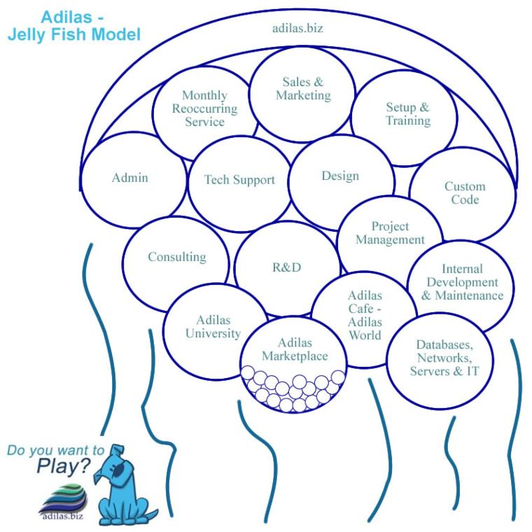
- Do you like the jellyfish model? (Organized with a loose, flowing feeling. Adilas is the overarching umbrella and there are a number of sub departments or subsets.)

- Would you want to see something different (company structure)?
- What products and services do you think we should focus on?
- Alan – If we start here, it will affect the other responses and decisions.
  - We currently offer things on the lower end and/or more affordable levels. Do we want to stay there or how do we support our bigger, more demanding clients?
- Russell – If you get more niche specific you can really hone in that tool for that niche. Russell would like to really make a “platform” that could be built off of built onto, etc. The city in the middle of the valley. Let’s allow people to keep building off of that city.
  - Railroad type model – The railroad comes to town and then you need banks, hotels, schools, stores, etc.
- Steve – adilas café – A single user could have access to any system, any server, via one login. The café would end up being a starting spot… what do you want to do? Buy, sell, play, work, participate in the community, etc. Let the users see and manage their profile and working area.
- Cory – Even on the support and service side, do we want to take that to the next level? Some of our clients are lost due to lack of quality control (where to go and how to stay on the path).
- Kelly – We need to keep our good people. We have seen it where good people get pulled over to more stable options. We really want our people to stay with us. There is some come and go, but that hurts sometimes. How can we support our people?
- Do we want to continue to internally fund this or seek outside investments?
- What do we need on the management side? What do we need in leaders and managers? Traditional managers? Or more of a Board of Trustees or Advisors?

- Do we want some sort of internal loyalty system or revenue sharing plan?

- How do you play? What is your time commitment, scheduling, maxes and mins (hours per week/month)?

- What business verticals are you interested in?

- Where would you like to focus?

- What are your thoughts on look and feel for the application interface?

- Let’s talk pricing. What are your thoughts?

- What about marketing and sales?

- What about code, databases, automation, testing, deployment, and other techy stuff? Back-ups, redundancy, mirrors, servers, clusters, etc.

- What are your thoughts on education, training, and add-on services?

- What about custom and API sockets and integrating with other external products?

- If we do a trust what are the other rules or parameters we want to set up? Is it just time, is it time and money, is it investment, what is necessary if you want to buy in? How do we determine who is active and not active? How many virtual family members do we want? Etc.

- Where do you see us (as a company) in 1 year, 5 years, 10 years?

- Where do you want to be in 1 year, 5 years, 10 years?

- Other ideas and thoughts?

