Presentation Gallery Outline

Attributes
- One System
  - What does that mean?
  - What would it cost?
  - Do I have to pay for different pieces?
  - Modular or all in one?
  - Does it really cover all of my business needs?
  - Is it expandable?
  - How deep does it go?
  - You've been waiting for this
- Customizable
  - Branding
  - Look and feel
  - Settings
  - Permissions
  - Page flow and processes
  - Add or subtract fields and values
  - White label
  - Custom dashboards
  - Custom reports
  - Custom code
  - Custom design
  - Custom database
- Powerful
  - Business Functions
  - Tools
  - Features
  - Processes
  - Automation
  - Exports of data
  - Custom reports
  - Mobile
  - Web based
  - Adaptability
- Dynamic
  - Relational model - one to many
  - Scaleable
  - Flexible
  - Custom naming conventions
  - Custom field options
  - Show/Hide settings
  - Settings
  - Configuration options
  - Navigation
  - Everything
- Cloud Based
  - Any browser
  - Access
  - Storage
  - Up time
  - Auto upgrades
  - No hardware or software requirements
  - Anywhere
  - Any time
  - Any device
  - Convenience
  - Centralized data
  - Collaboration
  - Minimal IT requirements
  - Paperless office
- Unlimited
  - Users
  - Usage
  - Locations
  - Invoices
  - Customers
  - Inventory
  - Storage
  - Processing
  - Corporations
  - Advantages
  - Access
  - Potential
- Results
  - Analytics/stats
  - Reports
  - Data
  - Business Intelligence
  - Exports
  - Monitor business health
  - All Data Is Live And Searchable
- No Contracts
  - Month to month
  - Client satisfaction
  - No licenses
  - Yearly review
  - Self serve model
  - Full access to your data
  - No limits - devices & users

Business Functions

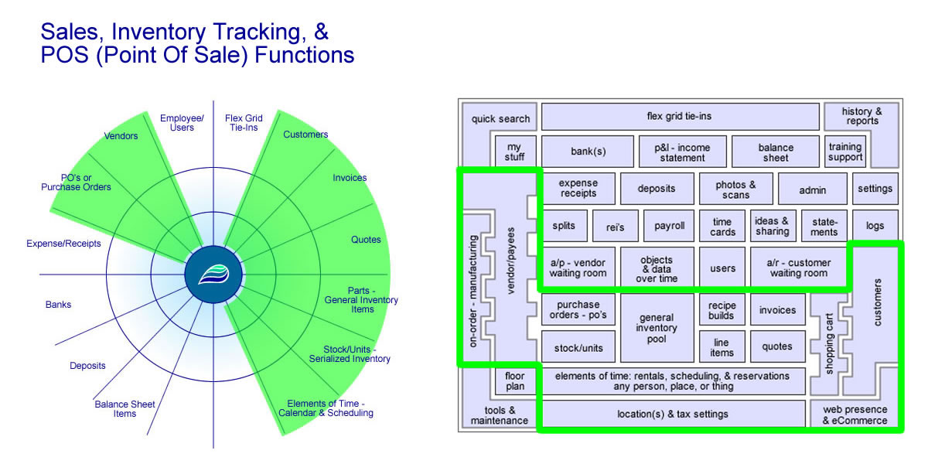
- Sales
  - Inventory tracking
    - Start to finish inventory tracking
    - Item usage histories
    - Unlimited
    - Reports & exports
    - Images, scans, multimedia
    - Units of measure
    - General items
    - Serialized items - stock/units
    - Time, labor, or services - unlimited
    - Fulfillment
    - Sub inventory - parent/child
    - Transfers
    - Internal builds - manufacturing
    - Ecommerce settings
    - Updating inventory counts
  - POS - Point of Sale
    - Invoicing
    - Quoting/Ordering
    - Secure shopping cart
    - Barcoding
    - Custom buttons
    - Discounts & campaigns
    - General items
    - Serialized items - stock/units
    - Time, labor, or services - unlimited
    - Locations & tax settings
    - Hardware options
    - Custom designs & layouts
    - Ecommerce tied to POS
  - Customer options
    - Loyalty points
    - Preset discounts
    - Purchase history
    - Payment history
    - Accounts receivable
    - Customer billing
    - Online bill pay
    - Images, scans, multimedia
    - Customer accounts
    - Reports & exports
  - Reporting
    - Sales reports
    - Profit reports
    - Daily/weekly/monthly reporting
    - Per locations, per salesperson
    - Deposits
    - Purchase histories
    - Trending items
    - Automated P&L
    - Exports
    - Advanced filtering
    - Save your own reports
  - Payment solutions
    - Normal POS options - cash, check, etc.
    - Merchant processing - credit cards
    - Online bill pay
    - 3rd party payment solutions
    - On account - customer credit
    - Custom configurations
    - Gift cards
  - Ecommerce
    - Real-time (live) inventory counts & tracking
    - Fully integrated systems
    - Online product purchase
    - Customer login portal
    - Online bill pay
    - View histories, statements, orders
    - Fulfillment
    - Fully configurable - settings
  - Other special functions
    - Work orders
    - Layaway
    - Recipe/builds
    - Hidden line items
    - Reoccurring
    - Barcode/QR code generators
    - Emailing capabilities
    - Discounting engines
    - Quantity tracking & thresholds
    - Loyalty points
    - Gift cards

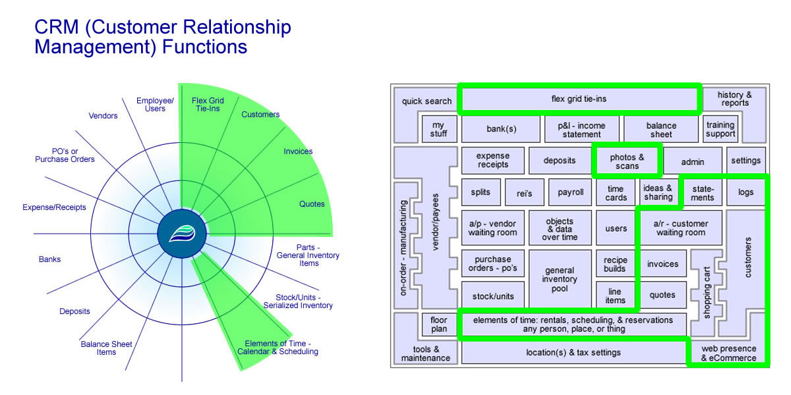
- CRM - Customer Relationship Management
  - Sales & purchase tracking
    - Payment tracking
    - Monies owed
    - Accounts receivable
    - Purchase histories
    - Invoices/quotes
    - Customer queue & sub-queues
  - Customer profiles
    - Holds additional information & subs
    - Log notes
    - Additional contacts
    - Reoccurring billing
    - Purchase & payment history
    - Groups & types
    - Preset options - discount & tax category
    - Photos, scans, files, media
    - Expandable custom fields
    - Manage relationships
    - Unlimited customers
  - Customer tracking & follow-ups
    - Unlimited notes & logging
    - Show/hide notes on calendar
    - Show/hide notes in customer portal
    - Purchase histories - What did they buy?
    - Accounts receivable - What do they owe you?
  - Calendaring & scheduling
    - Elements of Time
    - Reporting
    - Billing

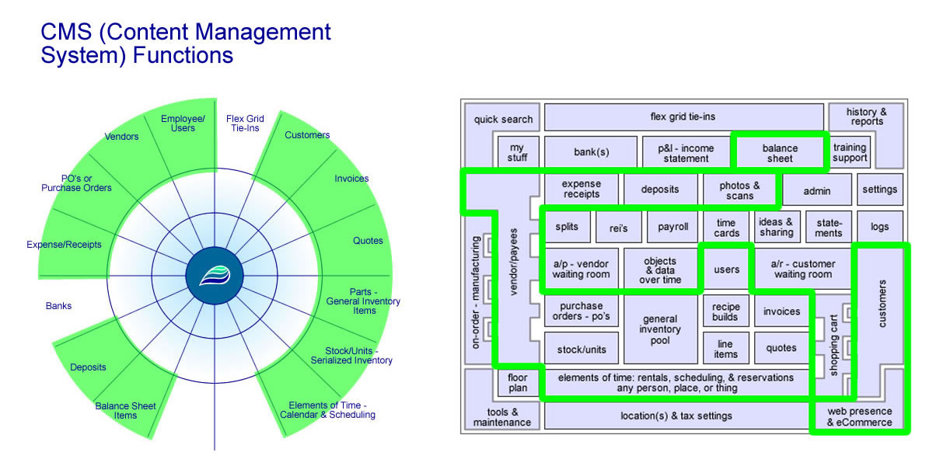
- CMS - Content Management Systems
  - Upload content
    - Permissioned
    - Image galleries
    - Files/Media/Content
    - Pre-filled custom documents
    - Digital story telling
    - Manage content relationships
    - Multi-file upload
    - Paperless office
  - Web presence & ecommerce
    - Custom controls
    - Categorize
    - Turn things on/off
    - Change web pricing
    - Show/hide things on web
    - Provide long descriptions, specs, reviews
    - Full ecommerce experience
    - Shipping options
    - Customer portal
    - Online bill pay
  - Data controlled content
    - Point & click interfaces
    - Template based & custom options
    - Permission based
    - Create unlimited content
    - Edit content & record histories
    - Advance content - virtual data assembly line
    - Business world building
    - Store, view, interact as desired
    - Backend logic based on content - cause & effect
  - Whole system
    - The whole system is technically a CMS
    - System look & feel
    - Backend layout & design - What’s under the hood
    - Built-in core flexibility
    - Custom anything - Dream it up! We’ll wire it up!
    - Data & content storage
    - Tracking all data interactions
    - Access points - who, what, where, when
    - Solid foundation of permissions & settings
    - Dynamic possibilities - Let’s grow together!
  - Hosted solutions
    - Cloud based
    - Ease of use - mobile, home, work, travel
    - Automatic updates
    - No hardware & minimal IT requirements
    - Built on multi-server environment - getting more than most businesses could afford on their own
    - Backups & disaster recovery
    - Data & system security
    - Managed services
    - Not charged per devices or per users
    - All system pieces in one spot
    - Interconnected & accessible
    - Access to support & training

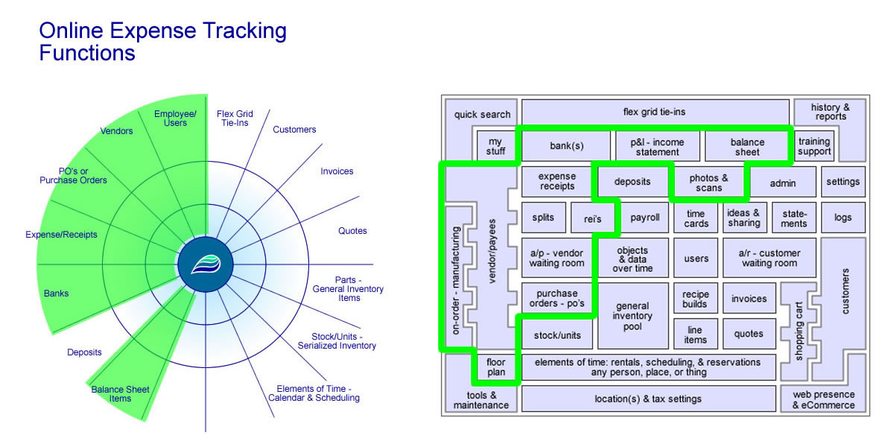
- Expense Tracking
  - Monitor costs for goods & services
    - Reoccurring & duplicating
    - View recent activity
    - Pay for inventory
    - Automatic flow through accounts payable
    - Normal bills & utilities
    - Employee expense accounts
    - Real-time P&L (Profit & Loss Statement)
  - Manage people & wages
    - Digital employee time clocks
    - Admin/manager time clock management
    - Salaries
    - Commissions
    - Payroll
    - Reimbursements
    - Reporting & exports
    - Remote check printing
    - Credit card expense accounts
    - Year end reporting
  - Full operational tracking
    - Multiple locations
    - Split payments
    - Aging & due dates
    - Multi-vendors assigned to expenses
    - All inbound inventory pieces automatically tracks into payables
    - Floorplans & stock/units - serialized inventory
    - Manage vendor discounts & credits
    - Custom grouping levels
    - Job/project costing
  - Track financials
    - P&L - Profit & Loss, Income Statement
    - Balance sheet
    - Expense types
    - Cost of goods sold - COGS
    - Payments on account - splits
    - Accounts payable
    - Per location, per type - chart of accounts
    - Reimbursements
    - Interest & loans
  - Documentation options
    - Scans, images, photos
    - Upload PDF & other documents
    - Attach receipts
    - Histories & audit trail
    - Digital storytelling
  - Banks & check writing
    - Unlimited banks
    - Account balances & registers
    - Custom check printing
    - Bank reconciliation
    - Point & click payments
    - Monitor outstanding checks

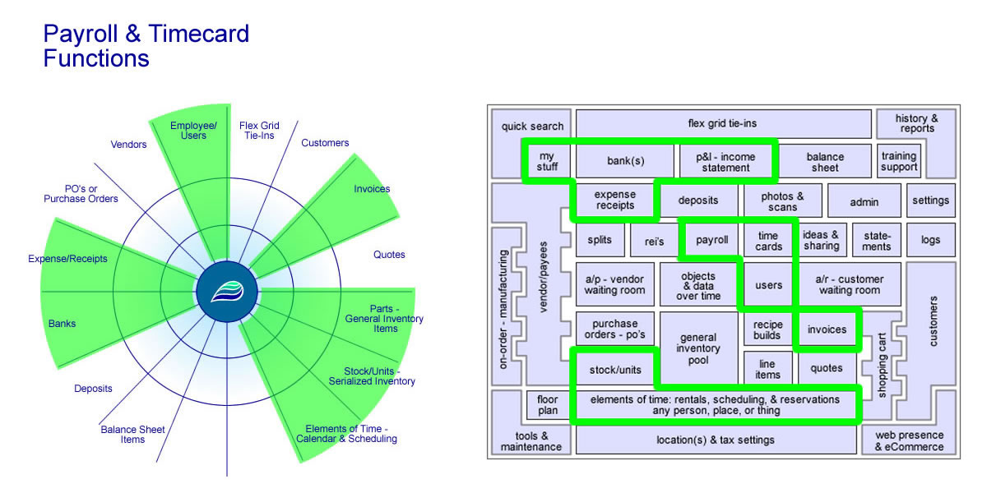
- Payroll
  - Employee options
    - Multiple departments
    - User profiles
    - Photo galleries
    - Files & media content
    - History tracking (logins, actions, audit trail)
    - W-2’s or 1099’s
    - Hourly, salary, commissioned, or mixed
    - Commissions & split commissions/sales
    - Digital paystub access
    - Individual time clock reports
  - Vendor options
    - Photo galleries
    - Files & media content
    - History tracking (usage, assignments, recent activity)
    - 1099’s
    - Full expense tracking
  - Time clocks
    - Employee time clocks
    - Manager time clocks
    - Admin time clocks
    - Multiple departments
    - Overtime
    - Bulk time cards
    - Project time tracking
    - Customer time tracking
  - HR options
    - Multiple departments
    - User profiles
    - Upload photos, files, content
    - Custom paperwork (contracts, forms, etc.)
    - Tax withholding settings
    - Bonuses, games, draws, IRA’s, meal plans, etc.
    - Permissions for employees, managers, and admin
    - Check writing
  - Reporting & forms
    - Full expense tracking
    - 1099’s
    - W-2’s
    - Other year end reporting
    - Commission reports
    - Sales reports
    - Payroll stubs & reporting
    - Export data
    - Custom paperwork
    - Printing options
  - Maintenance & updates
    - Automatic updates on tax withholding tables
    - Federal updates
    - State updates
    - Automatically flow into financials
    - Sub payroll & time tracking options
    - Forms updated annually
    - Custom paperwork & documents available

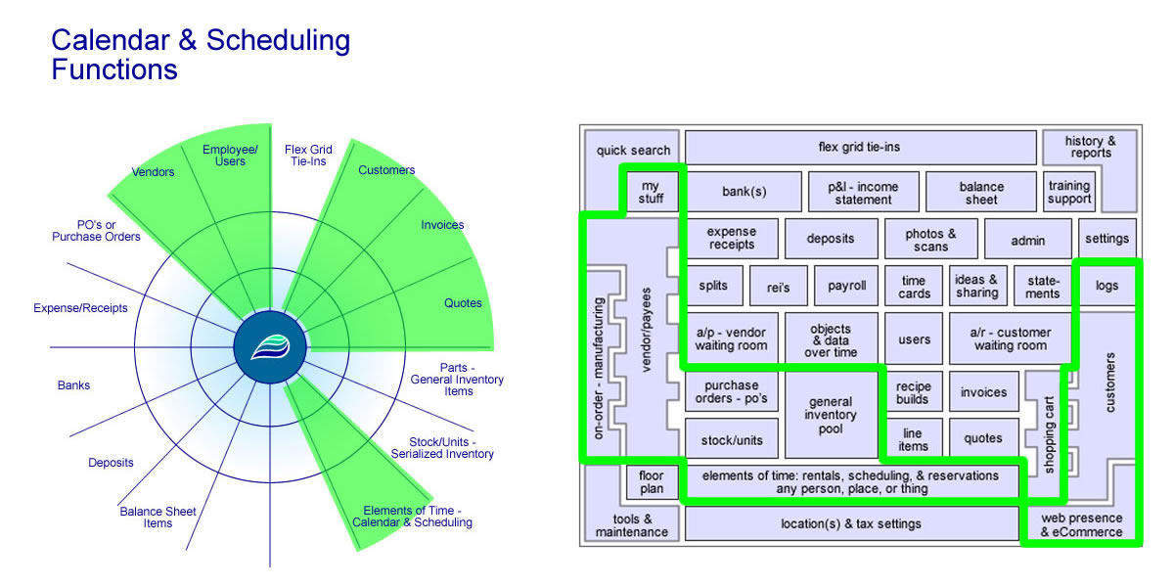
- Calendar
  - Permissions & settings
    - Time templates overview
    - Time template settings (setup & editing)
    - View only
    - Basic add/edit/view
    - Full admin access
    - You name it, you set it up, you use it!
    - Configurable ANY scheduler
  - Reports & views
    - Calendar view
    - Time slot view
    - Details view
    - Grouped reports
    - Advanced searches
    - Build your own report
    - Customize time homepage
    - Show/hide daily stats & log notes
  - Subs & functions of time
    - Project/job time tracking
    - Action status logs & changes
    - Date/times
    - Flags, tags, categories, types, locations, phases
    - Comments/notes
    - Sign-off's
    - GPS or RFID tag tracking
    - Payroll/time sheets
    - Notification/reminders
    - Tie-in's/assignments/pools ("any" person, place, or thing)
    - Like Legos - stack, layer, combine
  - Business connections & relationships
    - Tons of invoicing options
    - Quotes, vendors, users, customers, etc.
    - Dynamic toolset
    - Privacy & admin only settings
    - Flex grid tie-ins & custom fields
    - Photos galleries
    - Media/content or other digital files
    - Custom paperwork & documents
    - Sub-phases & checkpoints (data assembly line)
  - Other practical usages
    - Project/job tracking
    - Scheduling & appointments
    - Calendar events
    - Customer time clocks & billing
    - Sub locations, groupings, types, phases
    - Internal or external interactive blog or forum
  - Custom usages
    - Dispatching
    - Packaging & production runs
    - Internal communications
    - Rentals, reservations, advanced scheduling
    - Job costing
  - Custom wire jobs
    - Rosters
    - Ski schools
    - Race events
    - Event fundraising
    - Social media
    - Aid stations
    - Curriculum tracking
    - Behavior tracking
    - Community funded projects
    - You name it!

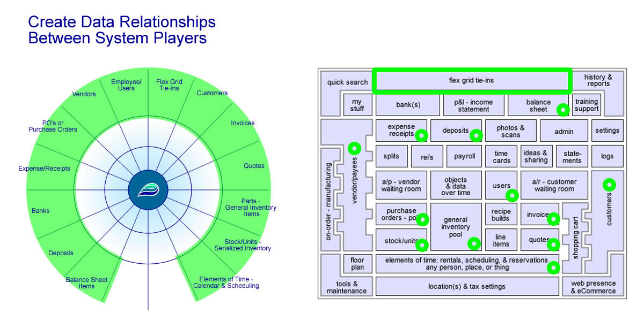
- Data Connection
  - Data
    - What is data worth?
    - Cloud based data vault
    - Business connections
    - People connections
    - Financial connections
    - Time connections
    - Little pieces - layering, stats, details
    - Databases - tables, rows, columns
    - One to many relationships
    - One to one relationships
    - Optional relationships
    - What is data to you?
      - Examples: names, numbers, addresses, people, product, accounting, flow charts, diagrams, natural progressions, data flow, mapping, drawing, connecting
    - You tell us
  - Natural connections
    - Employee/users to actions/usage
    - Corporation to locations
    - Customers to invoices & quotes
    - Inbound inventory - vendors to PO’s to items
    - Outbound inventory - customer to invoices to items
    - Inventory to financials
    - Invoice payments to deposits
    - Banks to deposits & expenses
    - Monies going out
    - Monies coming in
    - Time to everything
  - Flex Grid
    - Virtual buddy system
    - Link, stack, connect data
    - User-maintained connections
    - Custom data fields
    - Create your own mini database
    - History & log notes
    - Fully searchable
    - Tie data pieces together
    - Reflexive tie-ins - full circle
    - Save your own reports & export
    - Digital storytelling
    - Making custom software easy
  - Cause & effect relationships
    - Receivables tie to invoicing
    - Payables tie to inventory
    - Payables tie to expenses
    - Payables tie to items on account
    - Customers to purchase histories
    - Changes over time
    - Adaptive solutions
  - History & stats
    - Relational database model
    - Hundreds of tables with thousands of columns
    - Unlimited number of records & relationships
    - Building & progressing
    - Unlimited storage potential
  - Chaining & mapping
    - Chaining, blending, mixing
    - Transfers
    - Multi-location & usage
    - Stacking, depth, layers
    - Photos galleries
    - Media/content
    - Custom documents
    - Automation & creation
  - Systems
    - Interconnected system thinking
    - Everything under one roof
    - Bridging gaps, creating fluidity
    - Physical versus virtual
    - Processes/data assembly line
    - POS (Point of sale)
    - Inventory tracking
    - CRM (Customer Relationship Managment)
    - Expense tracking
    - Backend office & accounting
    - Payroll & timecards
  - Reports & exports
    - Anything you want
    - Web, pdf, Excel, csv
    - Preset standard reports
    - Build your own reports
    - Custom reports
    - Location specific
    - Scaleable multi-location
    - Files, images, scans
    - Digital storytelling
    - Data assembly line

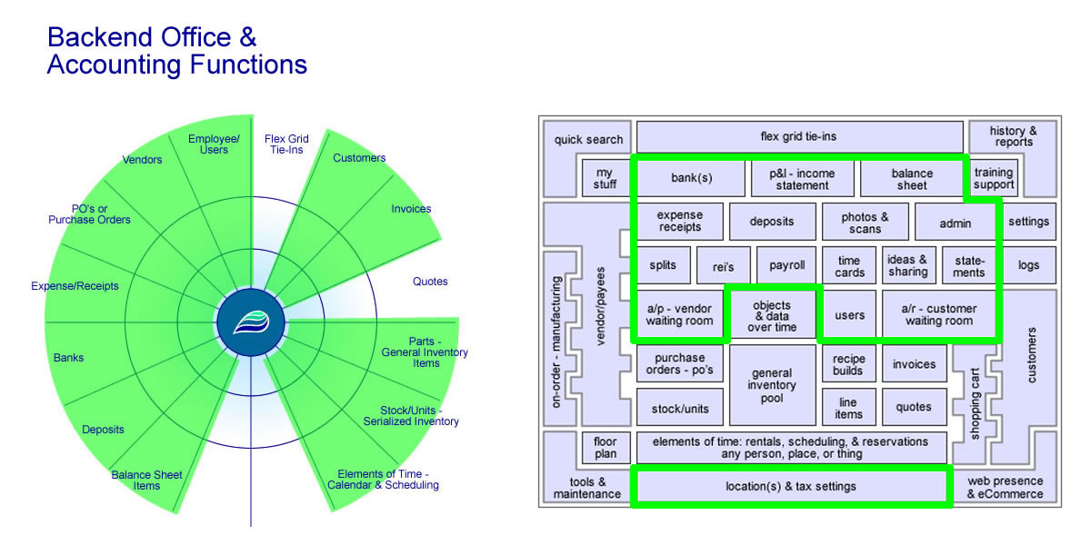
- Accounting
  - Your financial documents
    - Balance sheet
    - Assets, liabilities, equity
    - P&L - Income Statement
    - Revenue & COGS - cost of goods
    - Accounts receivable - A/R’s
    - Accounts payable - A/P’s
    - Bank registers
    - Inventory values & stats
    - Expenses & deposits
    - Invoices & PO’s
    - Real-time & living values
    - Full audit trail
  - Automation
    - Things on account
    - Aging
    - Loyalty points
    - Taxes & withholdings
    - Sales tax
    - Sub-inventory & perfect cost controls
    - Discounts
    - Financial flow
    - Full P&L
    - System-maintained balance sheet items
    - Accounts receivable - A/R’s
    - Accounts payable - A/P’s
    - You name it!
  - Natural flow & relationships
    - Relational database model
    - Operational led accounting
    - Inventory tracking
    - Banks
    - Expenses & reimbursements
    - Bill pay
    - Flex grid
    - Manufacturing & building
    - Daily, real-time, sharing
    - No batching/waiting
    - Cloud based watching
  - User-maintained
    - Allow for user interactions
    - Add/edit balance sheet items
    - Supporting transaction details
    - Layaway & work in progress
    - Equipment, vehicles, real estate, loans, etc.
    - Photos, media, content, custom documents
    - Stock/units & floorplan
    - Bank reconciliation
    - Bulk tools
    - Editable data with history
    - Phantom costing & slush funds
    - Shrinkage, theft, inventory adjustments
    - In-store credit
    - Sub accounts
  - Systems
    - 12 main players
      - Customers
      - Invoices
      - Quotes
      - General inventory items
      - Stock/units
      - Elements of time
      - Employee/users
      - Vendors
      - PO’s
      - Expense/receipts
      - Deposits
      - Balance sheet items
    - Cause & effects
    - Decisions & consequences
    - Characters & relationships
    - Working to solve problems
    - Solution thinking
    - Systematic design
    - Scaleable - mom & pop shop clear to enterprise
    - Multi-locations or multi-corp
  - Reporting & exports
    - Balance sheet
    - P&Ls - Income Statement
    - Accounts receivable - A/R’s
    - Accounts payable - A/P’s
    - Build your own
    - Save reports & favorites
    - All kinds of basic exports
    - All kinds of advanced exports
    - Payroll, time cards, & commissions
    - Drill-down to details
    - Okay feeding data to other systems
  - Future/non-traditional concepts
    - Objects & data over time
    - Digital storytelling
    - Data assembly line
    - Importance of dates & times
    - Modern glossary & terms
    - Business zipper - operations & accounting
    - Actively improving, designing, concepting, etc.
    - Momentum & vision
    - Pioneering & proof of concepts
    - World building
    - Community oriented - stone soup
    - 3D model - time, resources (money/people), space (depth/layering)
  - Purposeful design
    - Looking & taking the next steps
    - Operational led accounting
    - Mapping, translating & defining
    - Roll calling
    - Track life cycles
    - Flagging & tagging data - searchability
    - Permission levels
    - Closing the gap
    - Data supported numbers
    - Challenging tradition
    - What brings about change?
    - Optional usage
    - Great companion software package
    - Law of deference - defer to the thing that contains the most information

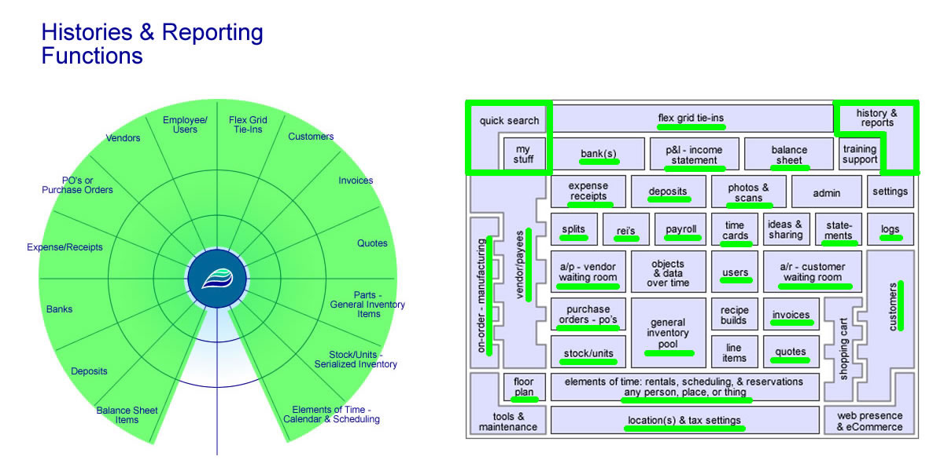
- Reports
  - Define the needs
    - Game of business
    - What is data?
    - What data points are needed?
    - Who sets those requirements?
    - Who gets to view? - Permissions & viewing status
    - Time frame - day to day, weekly, monthly, annually
    - What is the progression?
    - Looking forward - where is it going? Final destination?
    - Good data in = good data out
    - Simplify - one place to get your report
  - Catch the data
    - System thinking
    - Centralized the data
    - Categorize the data
    - Validate it
    - Media, files, photos, scans, etc.
  - Secure & store data
    - Standard data
    - Custom data
    - ADILAS - all data is live and searchable
    - Build your own reports
    - Data library - access as needed
    - Half of the entire application is reporting
    - Archiving
  - Transform & progress
    - Able to transfer to other systems
    - Transactional data to aggregated sums or totals
    - Labeling & barcoding
    - Scheduling & automation
    - Custom paperwork
    - Fill out specific forms
    - Flags, tags, & phases
    - Concepts of data assembly line
  - Show & filter
    - Saved favorite reports
    - Every section - basic & advanced searches
    - Multi-locations
    - All sorts of filters & criteria
    - Drill-down to data details
    - Prove it by the details
    - Roll call
    - Open access 24/7
  - Reporting uses
    - Exports
    - Archiving
    - Built on browser technology
    - Compare with multiple windows, tabs, split screens, etc.
    - View PDFs, Microsoft Office, Open Office, CSV
    - Mobile ready
    - Both secure & public reports
    - API sockets & raw data
    - Business intelligence
  - Quick search
    - Access from every page
    - Reports - show & view
    - Navigate - go & do
    - Tied to permissions
    - Tons of key word actions - home, new, last, adv, basic, numeric ids, text
    - Go anywhere in the system quickly
  - Dealing with time
    - Everything is based on time
    - Dates, times, & time stamps
    - Life cycle tracking
    - News & updates
    - Scheduling & calendaring
  - Permissions & view only
    - 100+ permissions
    - Permission check on every page
    - Your data
    - We help you store it
    - You pull it as needed
    - History & audit reports
    - HR pieces
  - Common reports
    - Inventory
    - Expenses
    - COGS
    - Financials
    - Banks
    - Transactional data
    - Maintenance logs
    - Compliance
    - Oversight
    - Reports for CPAs
    - Reports for investors
    - Warnings, thresholds, notifications
    - Payroll & time cards
    - Taxes

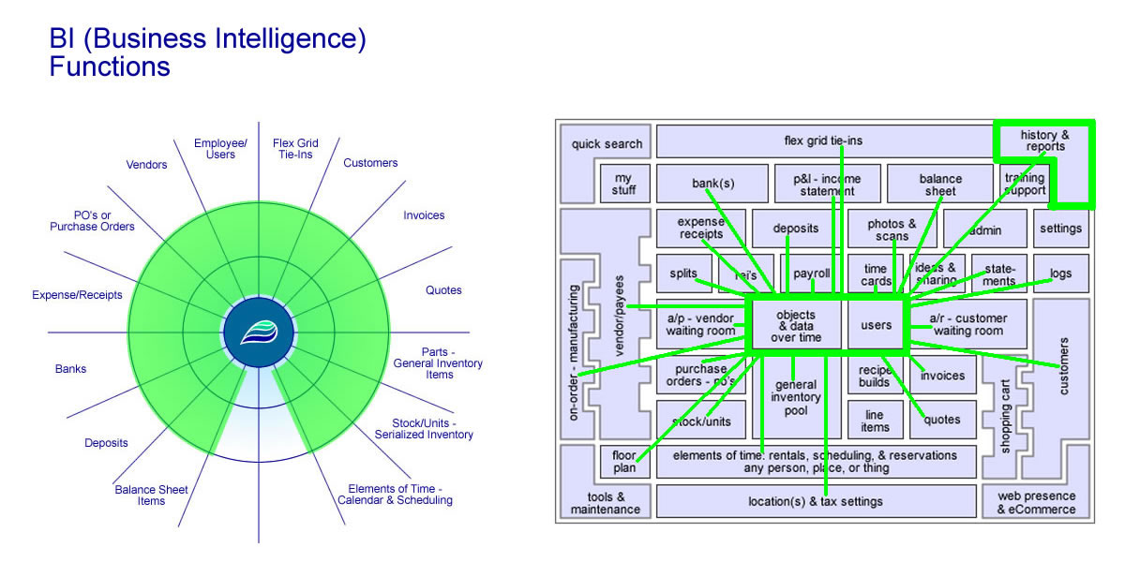
- Business Intel
  - Making informed business decisions
    - View at a glance
    - Automated reports with aging, search & filter options
    - Already designed reports or create your own
    - Stay connected wherever you are
    - Good numbers for accountant
    - CRM - Customer Relationship Management
    - Customer history
    - Year-to-date reports
    - Customer photo/document gallery
    - Drive profits
  - Types of intel
    - Roll call - real time when you need your data
    - Update inventory counts
    - Operations intelligence on what is happening
    - Financial & backend office accounting
    - Bank transfers
    - Floor plan - business intel for funding serialized units
    - Reconcile banks
    - Manager's checkbook - slush funds
    - Up logs & follow-up logs
    - What our clients want - quick and reliable access to counts, sums, averages, maxes, mins, stats and reporting
  - Power is in the data
    - BI can help drive revenue
    - Mixing & blending
    - Virtual assistant
    - Document anything
    - Add photos, scans, docs, etc.
    - Unlimited search potential
    - Five (5) decimal accuracy
    - Build your own reports
    - Profit per line reports
    - Peace of mind
    - Transactional data core - start here - then be able to roll up the data into enterprise aggregated levels
  - Conquering gaps and needs
    - Years of listening & providing solutions
    - Bridging the gap between operations & accounting
    - Centralize the data
    - Interconnected system
    - Objects & data with structure going over time
    - Things start playing through their life-cycles & relationships without multiple entries (double, triple, quadruple, etc.)
    - Eliminate errors - if data is good let it flow to the next stage
    - Brings value, reliability, & closure for business intelligence
    - Gap analysis - where are we vs where do we want to be?
      - Questions you might want to ask:
      - Where is the low hanging fruit?
      - What is working well for you?
      - What do you want?
      - What’s the difference in the middle - this is the gap?
      - What’s the plan to get what you want? We can help!
    - Feedback & ideas from users
    - Build data relationships
    - Big need for exports and imports
    - Bulk tools
  - Real-time reliability
    - Live and searchable
    - Optimized for multi-windows or multi-monitors
    - Digital filing system
    - Aged reports
    - Loan calculator w/amortization
    - Profit & discount calculator
    - Sales tax reporting
    - Use API sockets to build out the totals
    - Dashboards
  - Permissions and levels
    - Security
    - Empower people to do their jobs
    - Customizable roles for each user
    - Based on permissions - allow or deny access
    - Features change based on permission
    - 100+ permissions
    - Enterprise, consolidated, multi-faceted
  - Activity and history
    - Digital filing system
    - Every penny in, every penny out
    - Recent activity and history - real time
    - Search, save, store, & print
    - Scan your documents
    - Store your photos
    - Archive your documents
    - Track your processes the whole way through - every stage
    - Full audit trails
    - What changed? Log it
  - Cloud based platform
    - Access options
    - Remote, mobile, any device, 24/7, holidays, weekends, anytime, anywhere you can connect
    - Safe & secure using latest web based security options
      - 3 way checks on every page
      - Encrytption, SSLs, or https
      - 3 strike out login policy
      - Server-side validation, commercial level scripting, secure data center, & robust database servers
      - Daily backups, 24/7 support staff/techs - your data is in good hands!
    - All your numbers in ONE place
    - Operation driven accounting
    - Cloud accounting
    - Real-time environment
    - Paperless office!
    - Know where you're at daily!
    - All under one roof
  - Looking to the future
    - Actively pioneering, building, & improving
    - Heading toward full world-building - what does your world look like?
    - Challenging tradition in ways that help you!
    - We’ll keep pushing on things & bringing pieces of the puzzle together
    - Huge idea farm - you are welcome to participate
    - Bringing more value over time
    - Data portal - an area where data can be secured but flow in and out
    - Organized and retrievable
    - Life-Cycle accounting
    - Roll call accounting
    - Linear accounting
    - Ice-down dates
    - Powered by adilas.biz - under the covers
    - Possibilities - everything we have we can use to empower other software packages
    - We love this stuff! We can help you too!

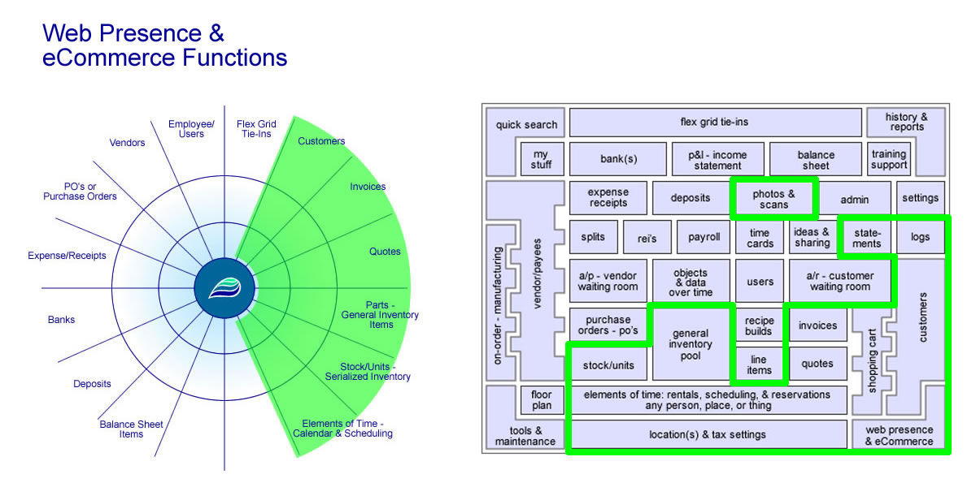
- ECommerce
  - Extension of your inventory system
    - Searchable web presence
    - Fully connected & integrated - both back-end & front-end
    - Do it once & have it cascade - enter once, use many
    - Mobile ready
    - Included in your subscription
    - Monitor real-time inventory counts
    - Sell anything you want
    - Stock/units - serialized or big ticket
    - Show all general inventory
    - Permissioned access - determine who can actually control your ecommerce stuff both at the settings and items level
    - Set special web prices or sales
    - Special reports to show web transactions
  - Configure everything
    - Tons of settings
      - Initial displays - landing pages
      - Tables & grids
      - Social media links
      - Discounting & coupon options
      - Light affiliate connections
      - Searchable parent attributes - helps in dynamic searches
      - Sell parent, unlimited, & sub inventory
    - Setup contact us pages
    - Location, category, & item level settings
    - Default images & full photo galleries
    - Items - long descriptions, specs, media/content, video links, etc.
    - Show like products
    - Change look & feel
    - Customize headers & footers
    - Determine login requirements
  - Customers
    - Ability to add new customers
    - Update their contact info
    - Full online ordering & ecommerce
    - Pay outstanding balances
    - Automatic email settings
    - Opt in & out for marketing campaigns
    - Build their own statements
    - Print or view any of their past histories - invoices, quotes, etc.
    - Run automatic discounts
    - Promotion codes & coupons
    - Show log notes & elements of time to customers
    - Require a login to show pricing or show pricing to everyone
  - Ordering and fulfillment
    - We can help you setup your process - what do you want or need?
      - Example: Online order happens, order shows up in system, can email both customer &/or specific users so they know action needs to happen, pull inventory & begin fulfillment process, prepare for pick-up or delivery, etc.
    - Real time, instantaneous changes - if you sell something in your store it automatically effects inventory counts online
    - Speed up process by allowing online pre-orders
    - Order converts quickly into an invoice
    - Prep before customer arrives or prepare items for delivery
    - Setup & harness alternate sales channels
    - Delivery, drive through, pick-up, drop-ship, sub queues
    - Print or email receipts
  - Shipping
    - Able to skip or include shipping
    - Simple flat fee shipping
    - Shipping based on items & weights
    - Advanced shipping matrices
    - Multiple ship to addresses - drop shipping
    - Send it wherever it needs to go
    - Shipping can be super simple or quite complex
    - We also offer custom solutions or processes
  - Merchant processing (credit cards)
    - Merchant processing is being able to process credit & debit card information online
    - Not required if you just want to use ecommerce for ordering (quotes) or just showing inventory
    - If you do want full checkout & payment options you will need a merchant processing account
      - https://www.adilas.biz/merchant_processing_flyer.pdf
    - Supported credit card gateways -
      - Authorize.net
      - USAePay
      - Others
    - Online bill pay - allow customers to pay, or finish paying, for bills or invoices
    - PayPal also an option
    - Special settings if you want to allow customers to checkout & pay later - on account
    - Coming soon - Stripe & Square
  - Emails and notifications
    - Email & notifications are not required but an available option
    - Configure & automate customer emails
    - Who needs to get notified?
    - Send copies of invoices, quotes, statements, etc.
    - Company or department emails - internal notifications
    - Customize look & feel, custom verbage, dynamic verbage, etc.
    - Warnings & thresholds
    - Email anytime - additional email settings within the backend system
  - Special features
    - Turnkey solution - turn it on & start using it
    - Ecommerce can be configured to none, all, or anywhere in between
      - You don’t have to use the full ecommerce pieces - use to whatever levels - suit your needs
    - Settings allow custom naming conventions
    - Alternate sales tax configuration for online sales
    - Ecommerce sales can still earn customer loyalty points
    - Invoice rounding - up or down depending on your specifications
    - Bulk tools
    - Training, videos, & free courses
    - 20-30 videos on ecommerce pieces & settings
  - API sockets & extensions
    - Think of a socket like an outlet in your wall that you plug into
    - An API socket is basically a way to call a function or method from an outside source or party - get access to the database through an external connection or socket
    - We are building out the API so that you can do the same things in whatever platform you want
    - 50 free public facing API sockets
    - You can turn these public facing sockets on or off - security options
    - Lots of 3rd party features & options - more to come!
    - 3rd party integration already connects Adilas with Woo commerce
    - Tons of help files & API socket documentation & samples
  - Custom - no problem
    - Built-in options with tons of settings that are very easy to use
    - If you want more, no problem, we can build to what you want
    - You can build your website or we can build it for you
    - Reconfigure your invoice &/or order process
    - Custom payment solutions, custom packaging/grouping/kits, custom shipping options, custom tracking & delivery options, etc.
    - Tons of custom code options, configuration, flow, display, & more
  - Keep building for the future
    - We’ve been doing this for a long time - lessons learned, wars fought, things to take into the future
    - Continue making it easier & easier by building to other features & extensions
    - Allow additional configuration
    - Rentals, reservations, booking time, scheduling features, signing up for courses, events, etc.
    - Accepting donations, community funding, & crowd sourcing
    - We are open to your ideas as well - come join in the community building effort

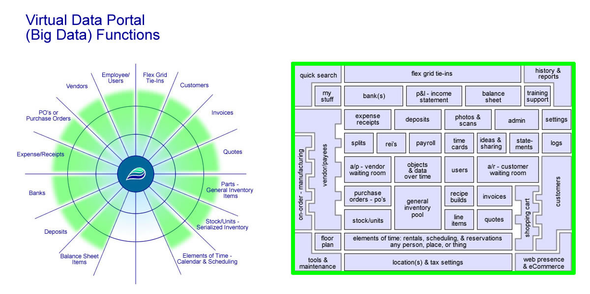
- Big Data
  - Where does it start
    - What does big data mean to you?
    - Once you have big data, what would you use it for?
    - What if you had a place for all of the data you wanted to hold & collect?
    - Every piece of data has a life-cycle - we help you track that
    - You get a huge interconnecting database - world’s best storage engine
    - We’ve designed & planned out most daily needs & tasks
    - Put control in your hands - enter data at the point of action
    - Save steps - enter once, use many - let it flow
    - Track & record operations & accounting
    - Built in & custom options
    - Technically you are building your own world
  - Big picture
    - Big giant umbrella - systems thinking
    - Sustainable
    - Digital story telling
    - Powerful, flexible, tie all your data together
    - Your business at a glance!
    - Insights that lead to business decisions & strategies - like BI (Business Intelligence)
    - Visualization
    - Trending and triggers
    - Pulling out hidden patterns and answers
    - Accurate forecasting
  - Centralized data
    - Ability to access, retrieve, & share all of your pieces
    - Fully relational databases
    - Paperless office
    - Digital filing systems
    - Cut your IT costs
    - Data warehousing
    - Quickly move around & navigate the system
    - Scaleability & data management options
    - Access & sharing based on permissions
    - Drill-down links to sub data or sub pieces
  - Flow through the system
    - As you feed the system it becomes like a living organism
    - Every piece of data tracked through it’s life-cycle
    - Data generates other data
    - If data is good let it flow - decrease duplication issues
    - Configurable plan to help with your processes
    - Improved efficiency - repeatable & reoccurring actions
    - Scaleable structure
    - Client side & server side validation
    - Tons of permissions & settings to allow access & automate flow
    - Sharing and transferring
    - Transactional data to summed up totals & aggregates
  - Cause & effects
    - Combining inputs & outputs
    - Things acting, interacting & playing together
    - Chaining & creating meaningful relationships
    - Stacking & layering - depth
    - Good data passes to the next step - data assembly line
    - Analyze, extract, & transform data
    - Capture, store, & provide views of the data
    - Operational efficiency will improve
    - Creating better customer experiences
  - No limits
    - 3V's of big data - volume, variety, & velocity
      - Volume (how much)
      - Variety (what)
      - Velocity (speed)
      - Two other V’s to consider:
        - Variability (when)
        - Veracity (quality of data)
    - What do you want? How much do you want? Game on!
    - No data caps
    - Unlimited - full integrated core with all tools
    - Different corps with same login
    - Build unlimited data relationships
    - Multiple departments, locations, corporations, etc.
    - Complex data sets
    - Size & quantity of the data - XS, S, M, L, XL, XXL - whatever!
    - Here to help you WHATEVER your size & data needs!
  - Hosted business solutions
    - Ownership of the data - it’s your data
    - SaaS - Software as a Service
    - With Adilas you get the entire core - all the business tools
    - Cloudbased - access any time - any device
    - Always up-to-date - automatic updates
    - Our team is daily working, refining, & improving the application
    - Real-time data portal
    - Safe and secure
    - Daily back-ups of code & data
    - Want your own back-ups? No problem!
    - No contract
    - Pricing based on your size & usage
  - Bright future
    - Peace of mind
      - Put things to bed
      - Safe & secure
      - Feeling of control
      - A nice warm blanket
    - Big data made easy
    - Quickly add/edit/view & get to your data
    - Even more pre-built reports, create your own, save, export options, you name it…
    - We are happily pioneering future methods & options
    - We see big data getting bigger, faster, & easier
    - Think of where this could go? Dreams, potential, & beyond
    - 3D business world-building

Application Players
These are your different toolboxes to get the jobs done! Each group is made up one or more individuals.
- Customers
- Invoices
- Quotes
- Vendors
- PO
- Parts/Items
- Stock/Units
- Deposits
- Expenses
- Users
- Balance Sheet
- Time

Core Concepts
Why and how does it work? Every company becomes its own world - virtual world building. What does your world look like?
- Capture & Record The Story
- Groups, Players, Individuals, & Characters
- Relationships
- Trouble, Problems, Needs, & Goals
- Decisions & Choices
- Consequences (Cause & Effects)
- Accountability
- Permissions & Settings
- Systems
- Vision & Future Developments
- Tech, Tools, & Maintenance
- Objects & Data Over Time

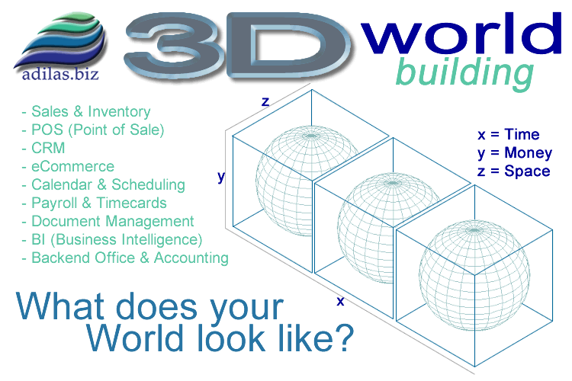
Moving Toward Full World Building
If you cut through all of features and bullet points above the end goal and idea is for you to be able to solve any of your business needs. A good portion of what we offer and peddle are hope, vision, potential, and making your dreams become reality.

This is why we are trying to introduce world building. The concepts of 3D World Building or Business World Building have been in the works for years. Adilas didn't start out with world building as the main goal. It kind of evolved from just taking one step after another, trying to solve our own business needs.
The goal is not just the operations, accounting, or the data. The goal becomes capturing the story with all of the details and interactions. It is the story that brings the dates, times, numbers, locations, and groups together.
Mixing all of the pieces together gives the values (data) or players (characters - pretend like it is a game) life or almost a personality. For example: Say all you know is we have $5,000 on 25th of October. That doesn't mean that much if that is all you get. But if you knew that the $5,000 on the 25th of October came from 20 different invoices at a single location that were collected and then deposited by John. That helps tell the story. Say you also had all of the underlying details of what each invoice was holding, what each customer bought or purchased, how much money was paid and how much was still owed... You could see inventory levels, notes, histories, trends, states, statuses, and other important details. Now you are getting a story. That is the goal!
