AI Agent Testing – Cart Functions
General Notes
I began my testing in the Yogen Früz Demo Site, but after discovering that no Items could be added to the Shopping Cart, I switched my testing to the Testing Playground, for which the AI Agent was configured.
The verifying of my Wallet was definitely a hassle, because I could not use the Berifyme scan of my Driver’s License, and had to use the Clear process. The next time I verified my Wallet, it was easier, but still a process, that I think should be required as infrequently as possible.
I never changed the AI chooser, so whichever one is the default, is the one I was using.
Actual Testing
- New Cart, New Customer Cart, and most of the Aliases, for those prompts, worked consistently, although one of the times that I said “start Cart”, I was taken to the page where you choose your Cart options.
- In a Customer Cart, when I said “add a customer to this Cart”, I was taken to the Customer Search page, which seems correct, however, the Customer searches did not accurately find the Customer profile. For instance, “search for customer Sean Carlton”, did not usually find my profile. Screen Shot:
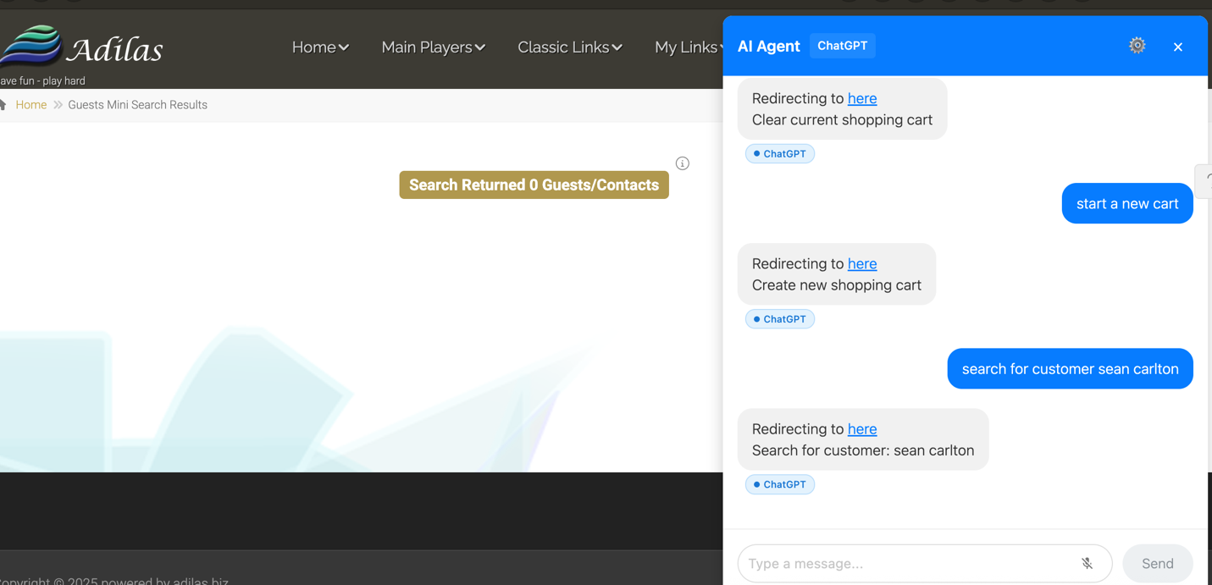

- Multi-action prompts do not seem to work, such as “new Customer Cart for last name Carlton” successfully found my profile, but when I prompted “start the Cart for this Customer”, no Cart was started. I would have had to physically click on “New Cart”, bypassing the AI Agent. Screen Shot:
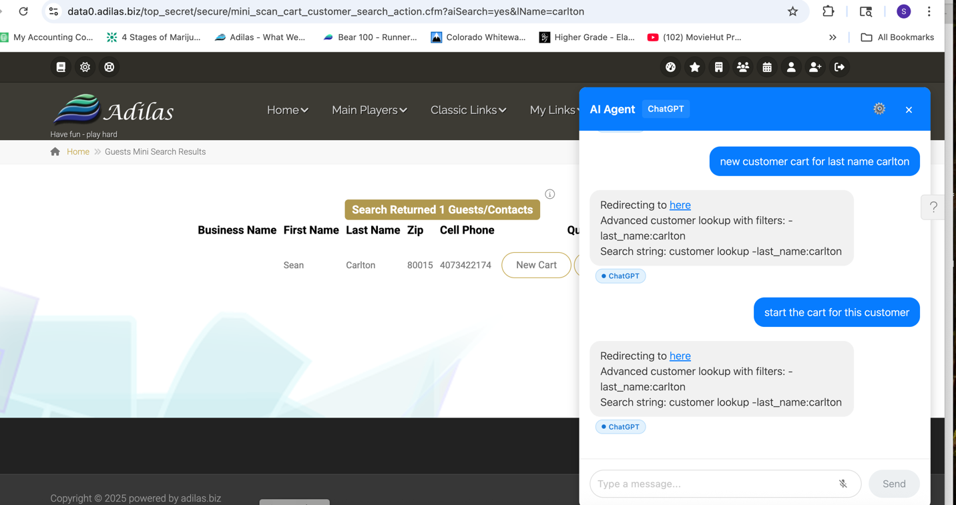

- Start Cart options worked as intended, by taking me to the page where you can choose Main Location and Cart Type.
- Adding Items to the Cart worked most of the time, but there was one prompt, “add Cocoa Puffs to Cart”, which added the correct Item on first prompt, but did not find the Item the second time I tried to add it, as seen here.
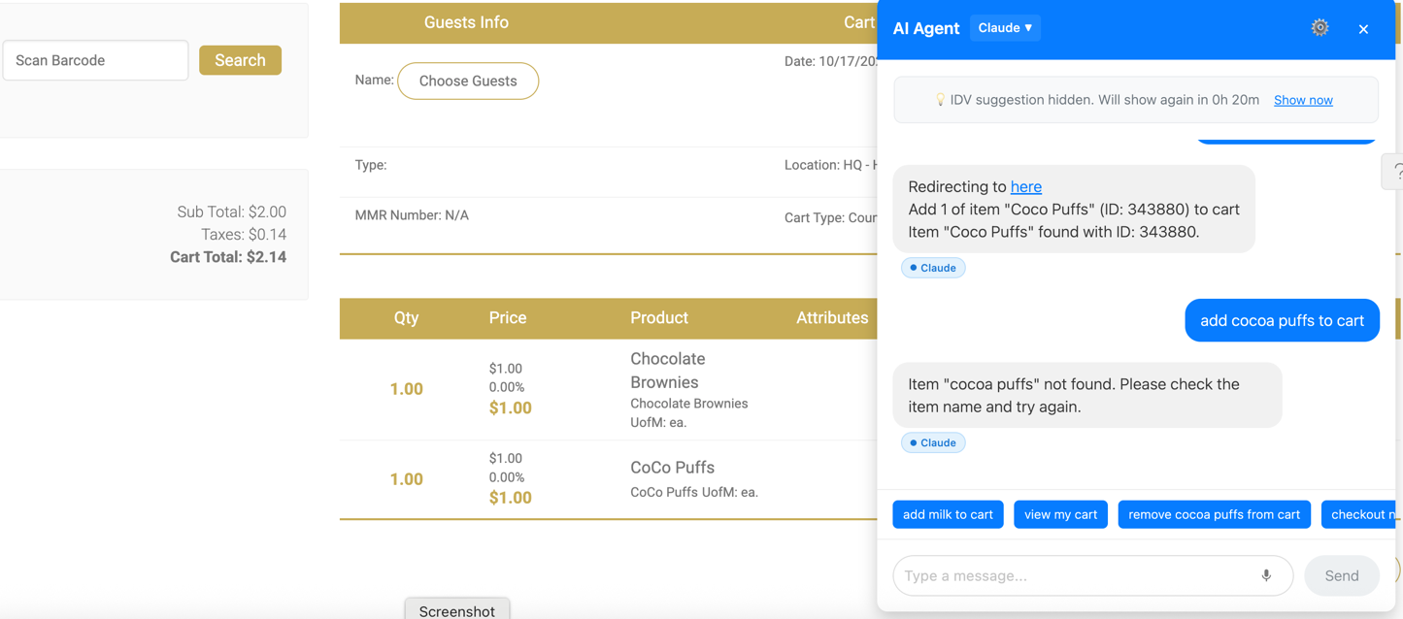

- On a different occasion, I had already added one Item to the Cart, and when I tried to add a second Item, I received an error about an AIT permission, as seen here.
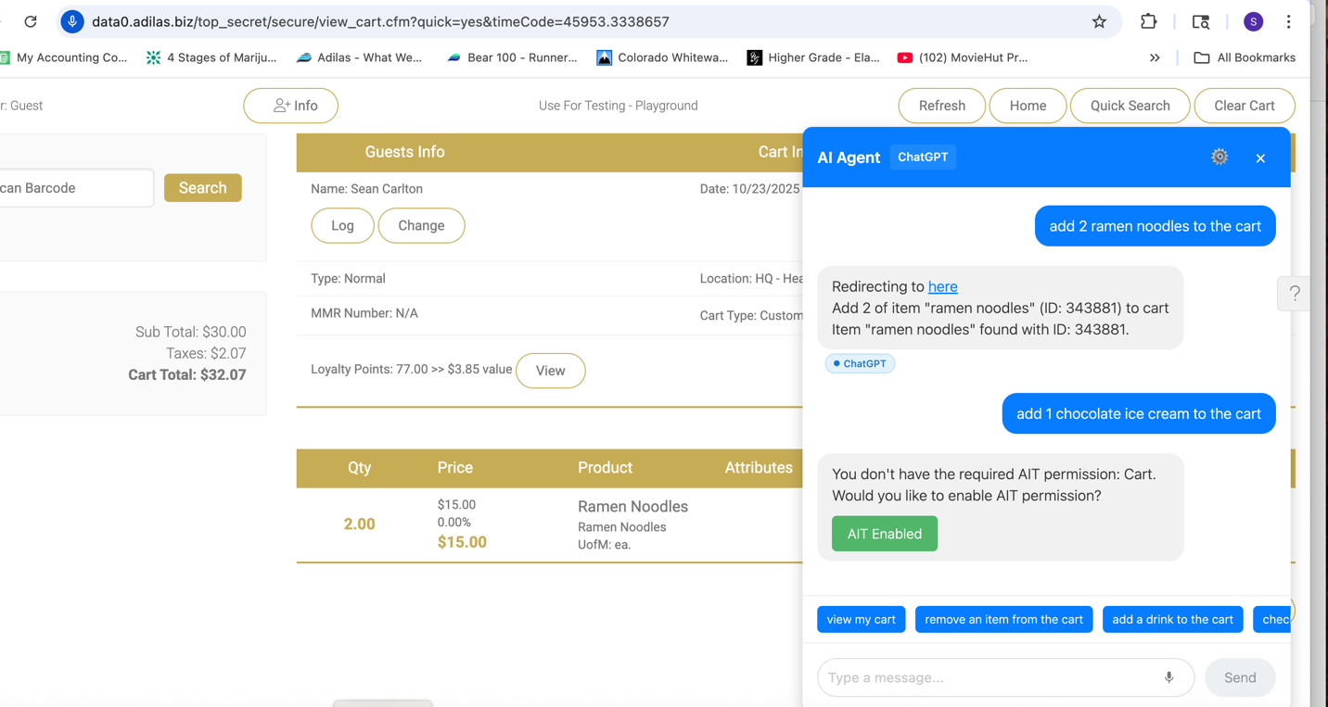
Still working in the same Cart, I realized that I had to check all of the Permission boxes again, which I did, and then I received this message.
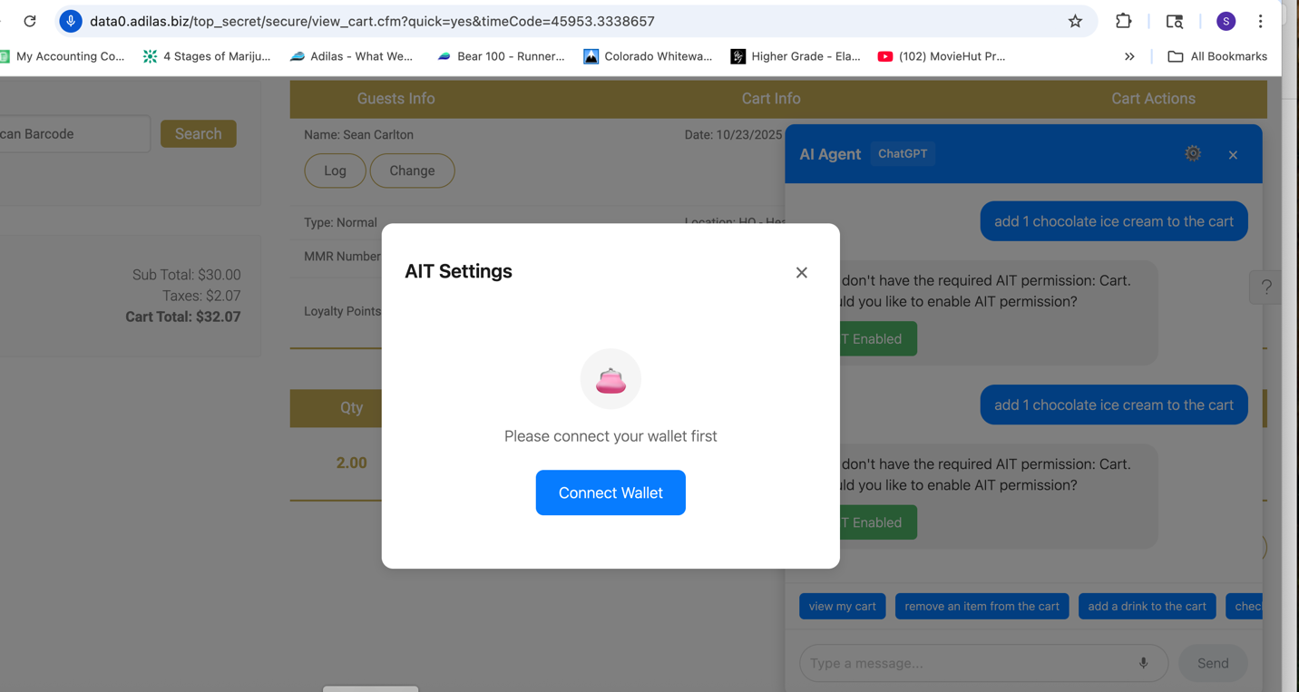
At this point, I tried clicking on the “Connect Wallet” button, but nothing happened. I was basically stuck, in the middle of a Cart transaction. Since that button was not active, I clicked the “x”, to close the window, tried to add the Item again, and got this message in the AI Prompt box, but was STILL unable to click the blue button, to connect my Wallet.
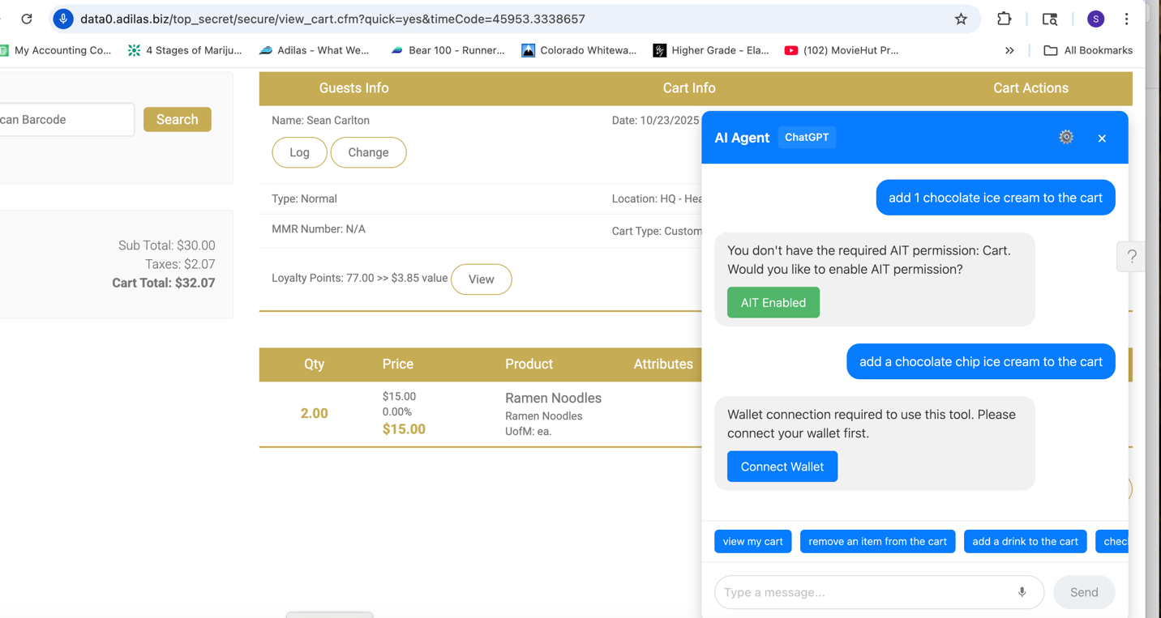
From here, I could not even ‘clear the Cart”, through the AI Agent, and had to manually clear it, and start over.
After manually clearing the Cart, and returning to my HomePage, the AI Agent was still locked up, and I had to logout of the Corp, and log back in.
Unfortunately, even after logging out, and back in, the AI Agent was still stuck in the same loop.
Even after completely shutting down my Chrome Browser, and restarting, I still could not use the AI Agent, as it was still saying I needed to “Connect Wallet”, but that button was not functional.
At this point, I had to end my testing session, so I shut down my complete system, to start again later.
Upon restarting my computer, and logging back into the demo Corp, the AI Agent was still saying that I needed to connect my Wallet, but finally, the button worked, and I was able to resume testing.
- “View Cart”, “Cart View”, and “Return to my Cart” all went to the already open Cart, as intended.
- “Clear Cart” and all the Aliases worked well in clearing the existing Cart.
- Checkout and most of its Aliases also worked, in that they took me to the Payment Screen, however, when I used the Alias “add payment”, instead of going to the payment screen, it asked more questions, as seen here.
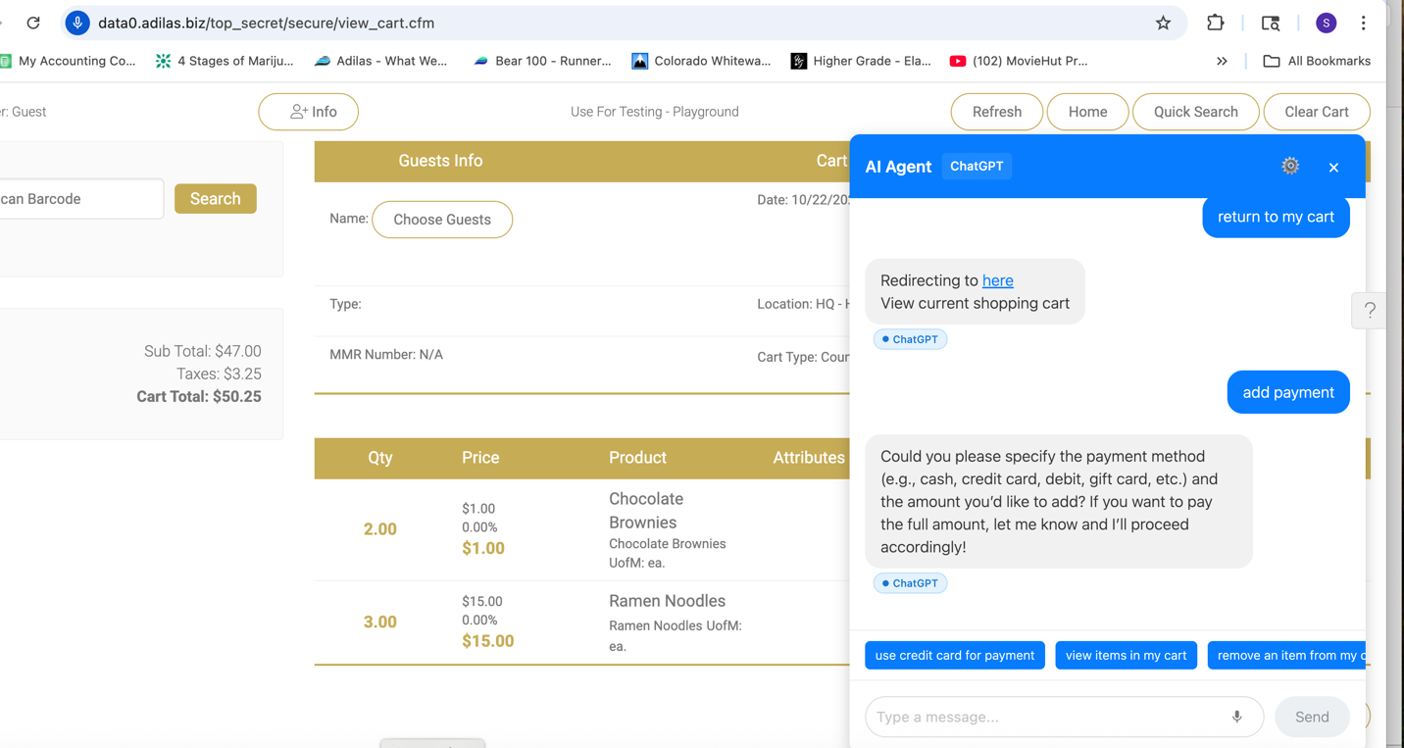
- After saying “add payment” a second time, when I received the questions as to payment type, I said “use $10.00 of Loyalty Points, the Invoice was immediately created, as a Cash payment. This might have been because there was no Customer in the Cart, and thus no Loyalty Points available, but it seems like a different question should have come up, instead of creating the Invoice. Also saying “ten dollars” resulted in the AI hearing $1000. See here.
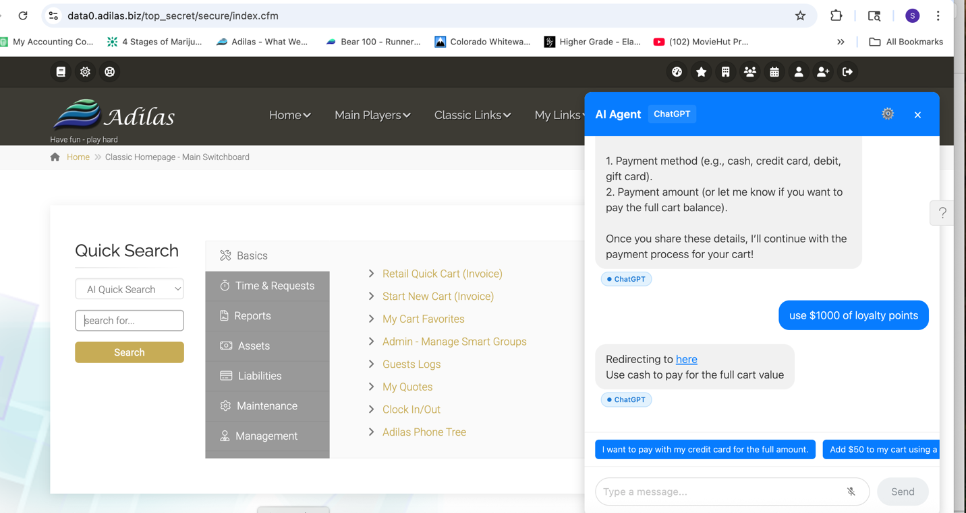
- Quick Cash and all of its Aliases resulted in a Quick Cash Invoice being created, which is correct.
- Cart Help and Shopping Cart Help resulted in a list of help Items, in the AI portion, but did not take me to a specific Adilas Page.
- Saying “Cart prompts” took me to the Adilas page with the Shopping Cart prompts list
- “My Cart Favorites” took me out of the Cart, and showed me all the My Cart Favorite buttons, which is probably intended.
- “Bulk Edit Lines” resulted in the correct page coming up.
- When I said “Discount Calc”, I was taken to the Discount Calculator, which is correct. “Open the Discount Calculator” did the same thing. When I was in the same Cart, and said “Add a 10% discount to the Chocolate Ice Cream”, I was taken to the Discount Engine, as seen here.
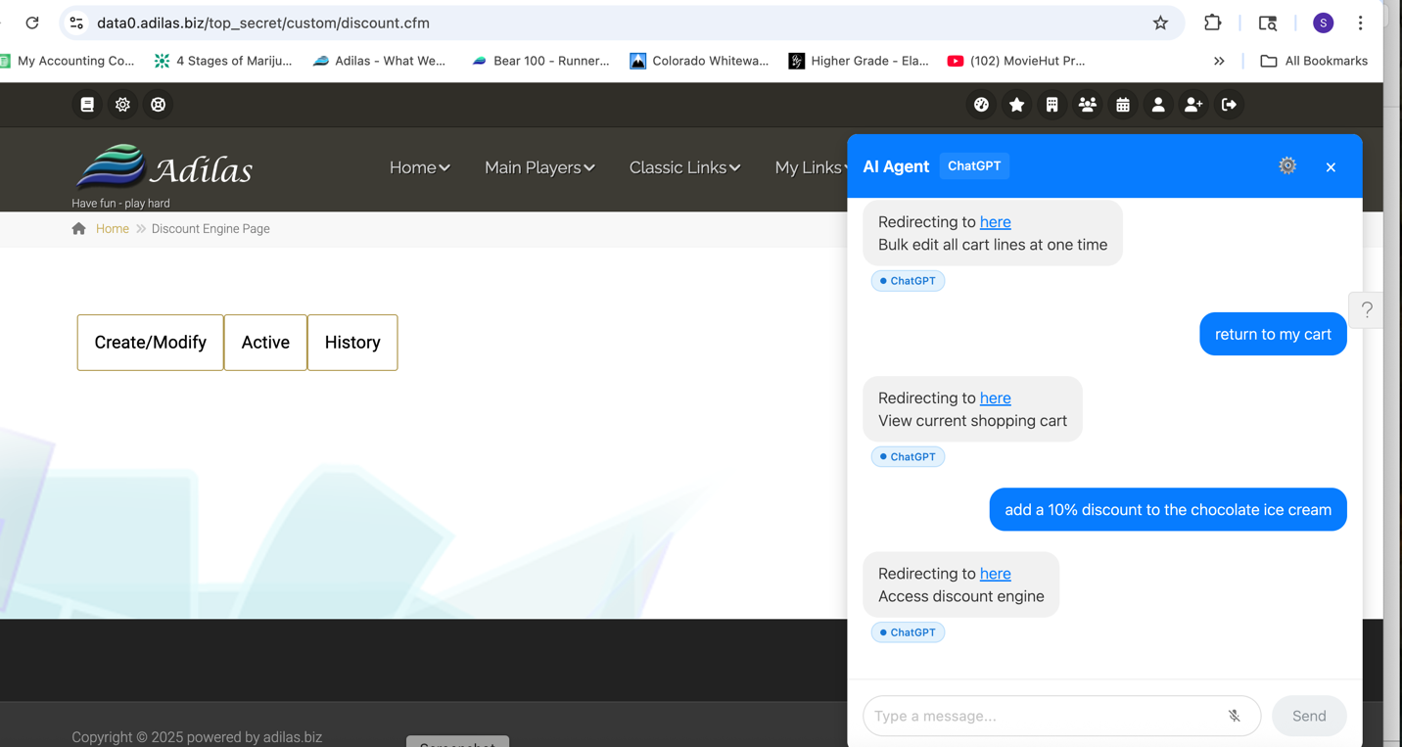
- Saying “Discount Engine” correctly took me to the Discount Engine.
- “bulk print Labels” took me from the Caret to the correct page.
- “cost profit per line” took me to the correct page, which showed the Line Items in the current Cart, along with the prices, costs and profits for each Line.
- “Split Cart” worked correctly, showing the buttons on the left and the Cart on the right.
- To try the next Split Cart prompts, I skipped to “Jump out of Split Cart”, and even though the AI reply said that it had been done, I was still in Split Cart view, as seen here.
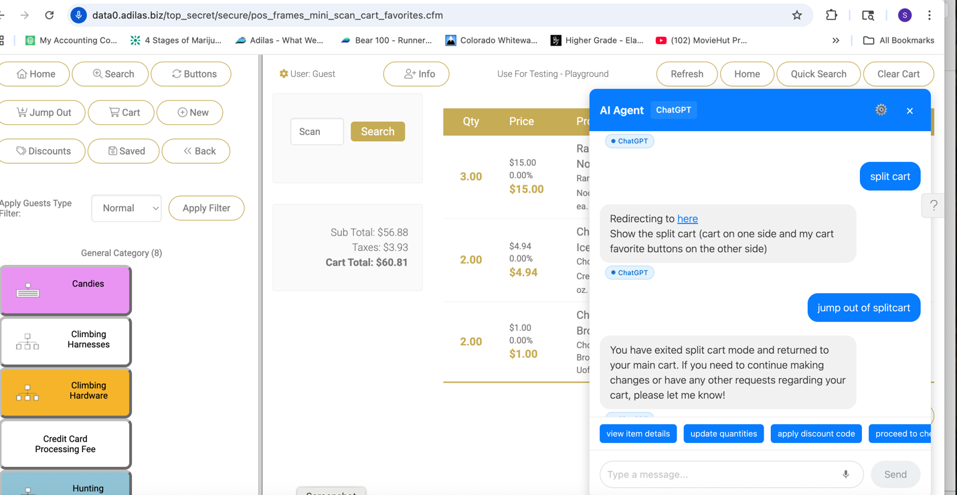
- After manually jumping out of Split Cart, I tried the “splt cart classic”, and this brought up the “classic” buttons on the left, and kept the same Cart on the right, which seemed correct.
- When I said “jump out of Split Cart”, the same thing happened where the AI reply said I was no longer in Split caret, but I still was, so I manually jumped out, to test the next prompt.
- “Split Cart Kush” also put me in Split Cart mode, but this time the Buttons were on the right and the Cart was on the left, which is probably correct.
- “Printable Cart” took me out of the Cart and into a printable version of it, which is correct.
- “Auto fill RFID Tags” took me to the bulk edit Line Items, which is probably correct, but this Corp does not have any RFID Tags, so kind of N/A.
- The final three prompts were not tested, but they seem to be multi Item arrays, and I just didn’t know the required Item ID Numbers to test, which most Clients probably wouldn’t either, since this is an Adilas generated ID Number.

