David C of Patriot Care is requesting automated grouped and cross corp consolidated reports within adilas. Reports should be able to be filtered by Hour, Day, Week, Month, Year. Reports should include a visual (graph).

All reports should be on one page or available by one click from one page.
He wants multiple people to have access to the reports so that operations can use it for ordering and production.

Reporting data points include:

People: New Customer Counts, Average Queue Time, Total Number of Invoices (Per Day).
Product: Sales, Purchase and Production Reports grouped by category (flower, pre rolls, edibles ect) and by weight (.5g, 1.75g, 2.5g, 3.5g, 7g ect).

- Settings / Filters at top of page:
  - Choose one, many, or All Corps (Phase 2)
  - Choose one, many or All Locations (Phase 1)
- Settings / Filter for Date and Display type
  - Default to todays date – provide to from dates.
  - Default to Day – select Hourly, Daily, Weekly, Quarterly, Yearly

Master Print- Print format for all 5 reports.

Header: People –
Report 1: Customer Report
New Count
Total Count – Drill down for by type.
Chart type:

Report 2: Customer Queue
Total Count
Average Queue Time (Start to Finish)
Average POS Time (start cart to finish)

Header: Product & Sales

Report 3: Sales & Profit

Category Weight QTY Gross Sales Net Sales Net Profit

Chart Type:

Report 4: Production
Category Weight QTY Total Extended Costs
Chart Type

Report 5: On Hand
Category Weight QTY Total Extended Costs

Chart Type:

Pate Settings:

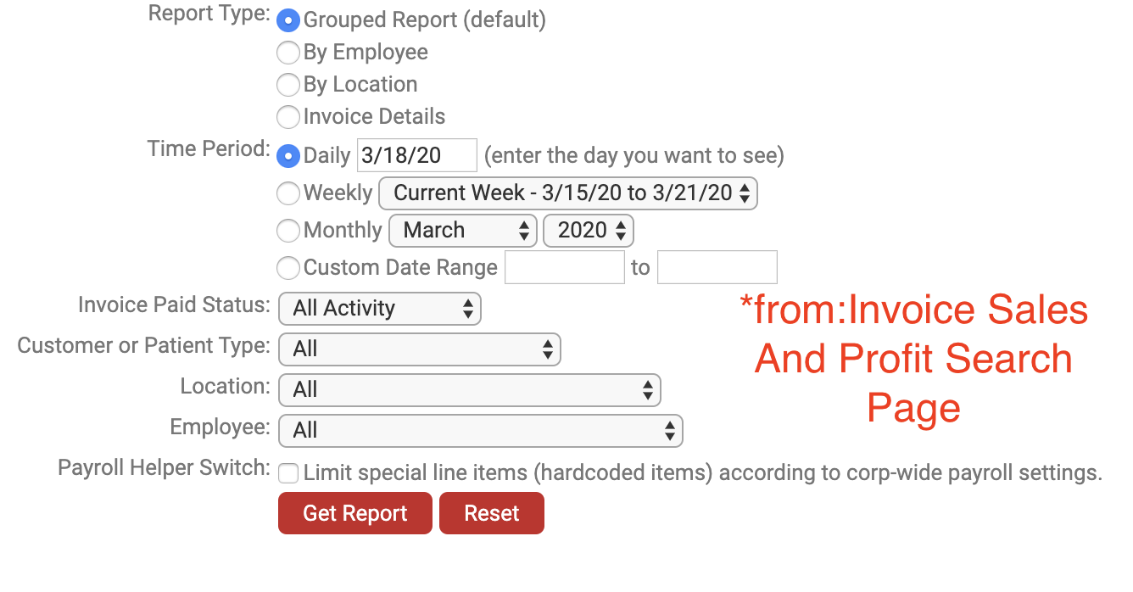
PRINT ALL Option: Print to PDF View

Customer Reports
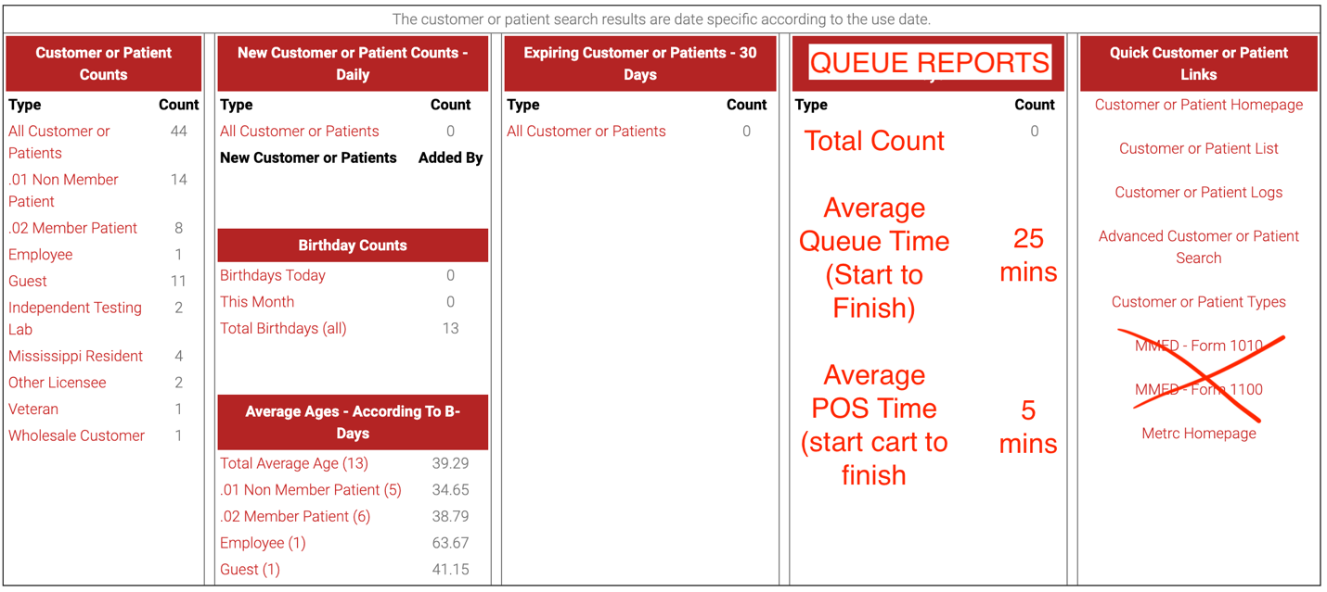(MMJ Operation Home Page)
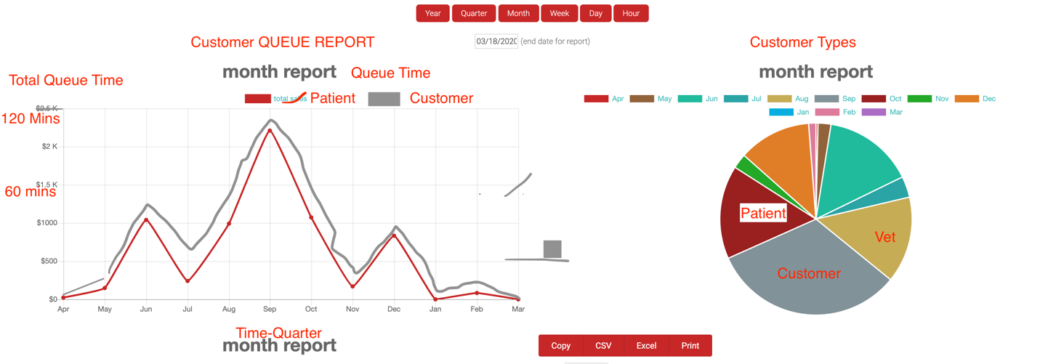

Sales Reports:
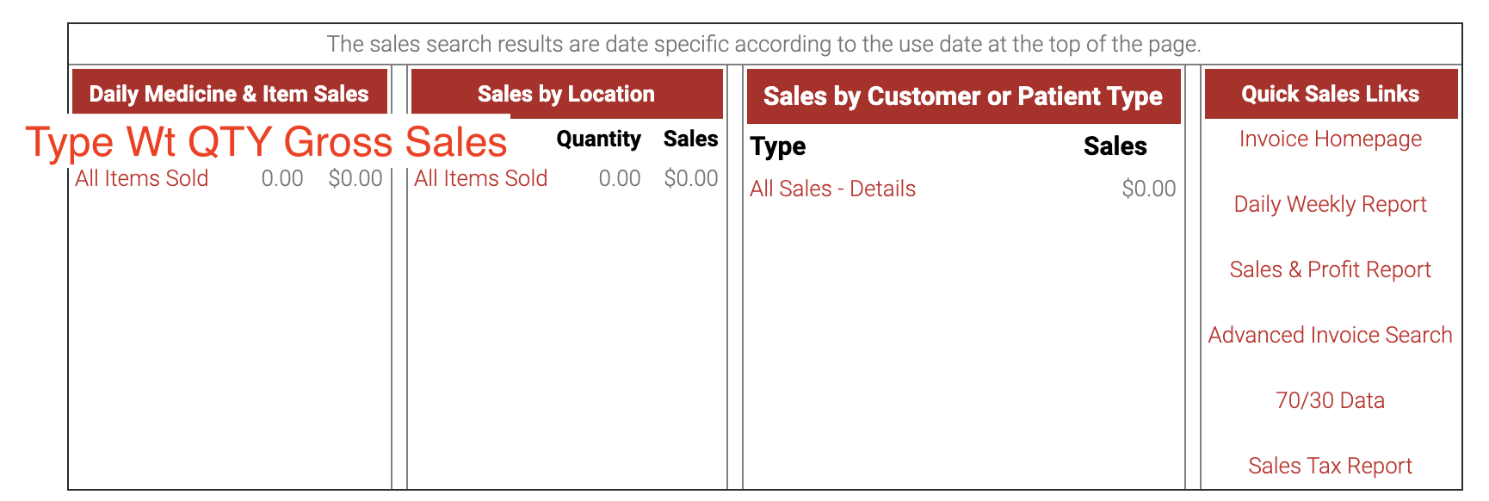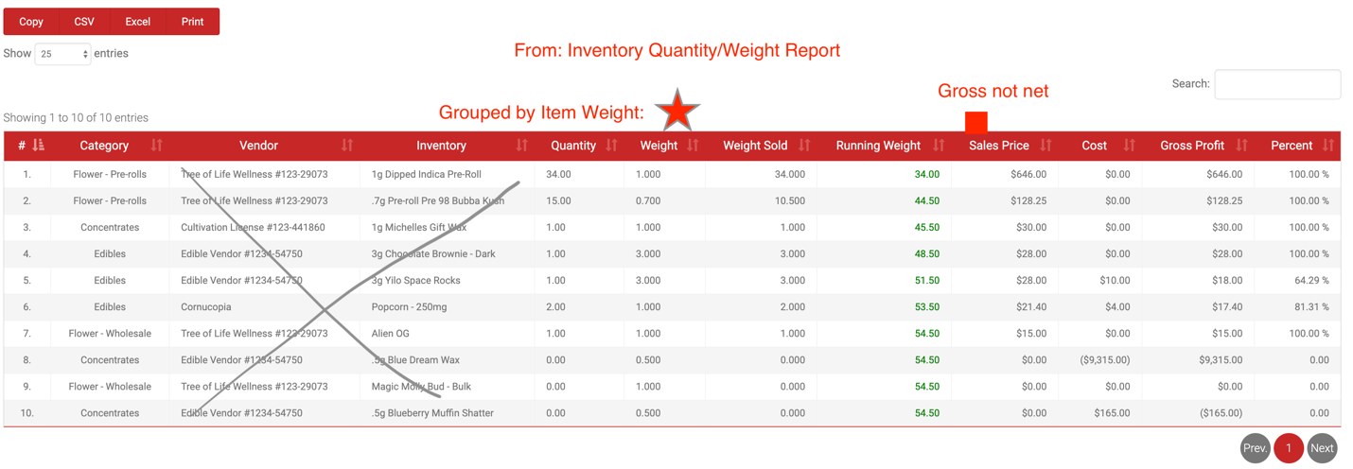
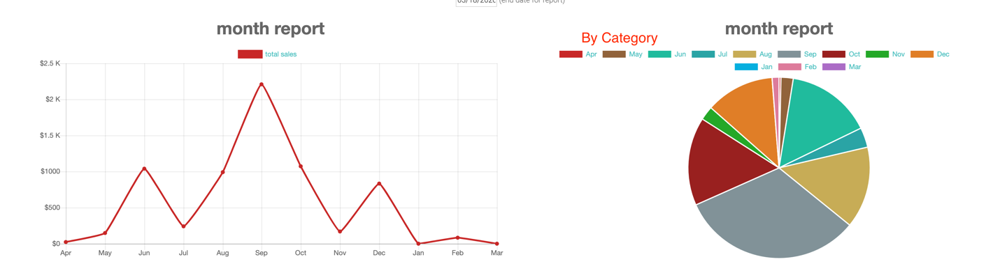
PO Reports
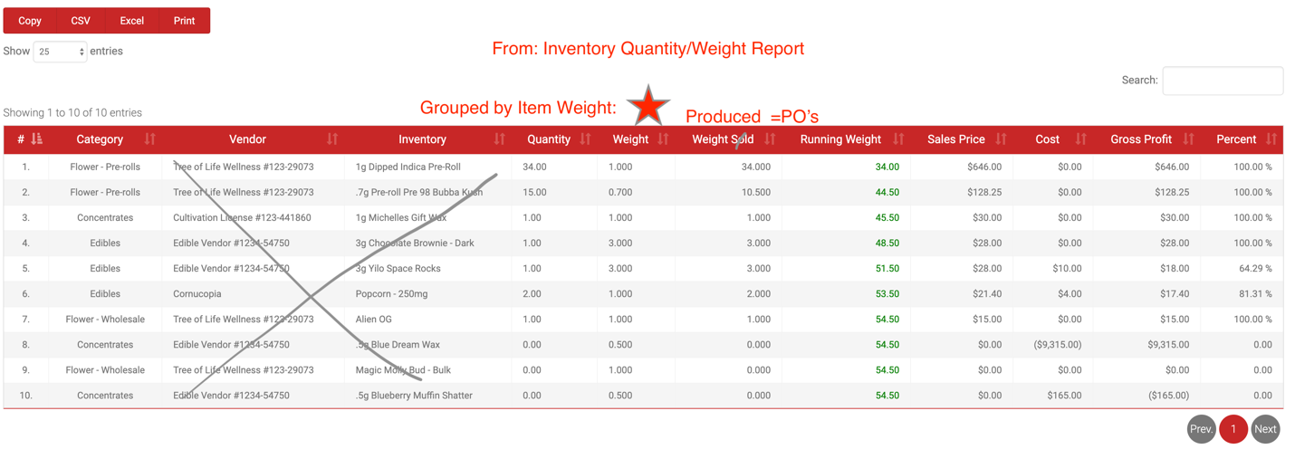
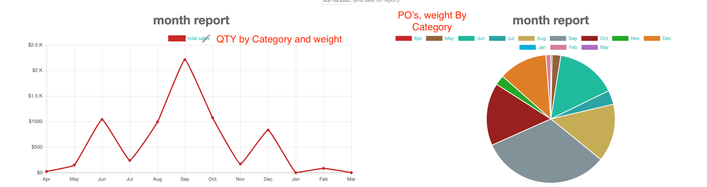

DRAFT Visuals:
Supporting Images:
- Settings & Report 1 & 2
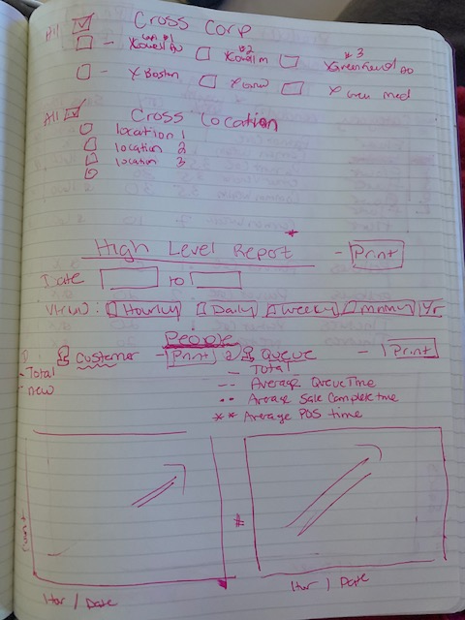

Report 3
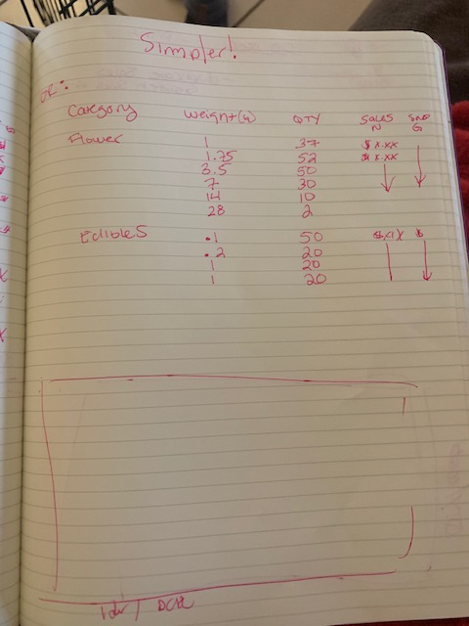
Report 4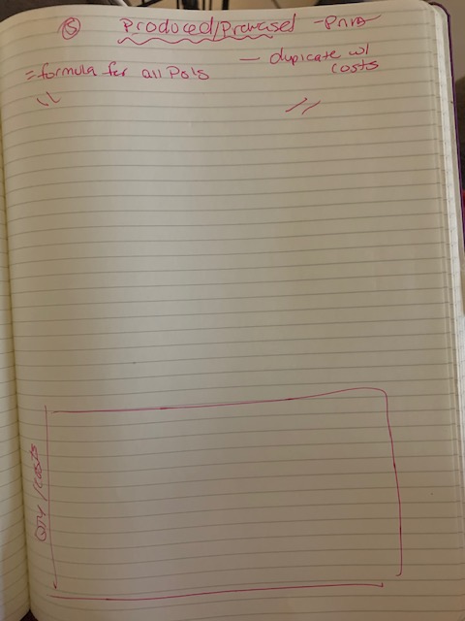
Report 5